
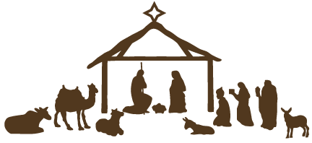


DECEMBER 2020

SUNDAY | MONDAY | TUESDAY | WEDNESDAY | THURSDAY | FRIDAY | SATURDAY
 | 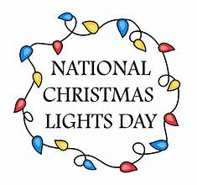  1  6:00 PM Dart Ball | 2  6:00 PM Rainbow Road Board  7:00 PM New Found Freedom-CC | 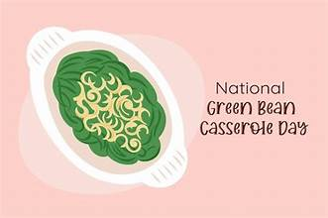  3 |   4 |   5 |   6  7:00 PM We Surrender-Church
7 (P)  2nd SUNDAY OF ADVENT  9:00 AM Communion (Union)  8:45 AM Sunday Bible School (First)  10:00 AM Communion (First)  11:00 AM Choir (First)  11:15 AM Communion (Ford)  11:00 AM Advent Event (First) | 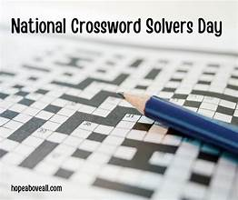  8 | 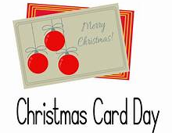  9  7:00 PM New Found Freedom-CC | 10  5:30 PM Choir   |   11  12:00 PM Seniors for Safe Driving-CC | 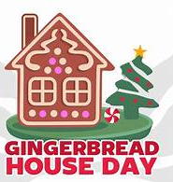  12 |   13  7:00 PM We Surrender-CC
14 (P)  3rd SUNDAY OF ADVENT  9:00 AM Worship (Union)  8:45 AM Sunday Bible School (First)  10:00 AM Worship (First)  11:00 AM Choir (First)  11:15 AM Worship (Ford)  2:00 PM Camp 43-CC |   15  6:00 PM Dart Ball |   16  7:00 PM New Found Freedom-CC |   17  5:30 PM Choir | 18  12:00PM SIFT-CC  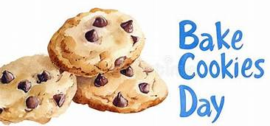 |   19 | 20  7:00 PM We Surrender-CC
21 4th SUNDAY OF ADVENT (P)  9:00 AM Worship (Union)  8:45 AM Sunday Bible School (First)  10:00 AM Worship (First)  Children’s Christmas Play (First)  11:00 AM Choir (First)  11:15 AM Worship (Ford) |   22 | 23    7:00 PM New Found Freedom-CC |   24  6:00 PM Christmas Eve Service (Ford)  Church Offices Closed | 25  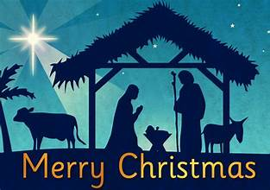 | 26   |   27  7:00 PM We Surrender-CC
28  9:00 AM Worship (Union)  10:00 AM Worship (First)  11:15 AM Worship (Ford)  Church Offices Closed | 29  Church Offices Closed | 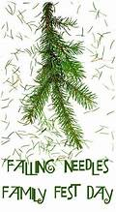  30  Church Offices Closed |   31  Church Offices Closed

