FIRST CHURCH WEEKLY CALENDAR
SUNDAY, November 9th
8:45 AM Sunday Bible School
10:00 AM Worship
2:00 PM Camp 43-CC

MONDAY, November 10th

TUESDAY, November 11th
1:00 PM Trustees
7:00, PM Nurture, Outreach, Witness
7:00 PM New Found Freedom-CC

WEDNESDAY, November 12th

Thursday, November 13th
10:00 AM Girl Scouts-CC

Friday, November 14th

Saturday, November 15th
7:00 PM We Surrender- CC

SUNDAY, November 16th
8:45 AM Sunday Bible School
10:00 AM Worship
December Newsletter Deadline

THE FLOWERS ON THE ALTAR are presented to the Glory of God in memory of Libby & Edna Stennett, given by Sally & Tony Krozely

THANK YOU to the following individuals for assisting with today’s service:
Usher Team: Oxford/Linda VanSicklin
Scripture Reader: Brenda Beers
Worship Sound System: Carlee Beers
Bell Ringer: Eliana McGregor
Welcome Center Greeter: Melissa Bureau
Acolyte: Jocelyn King
Live Stream: Brenda Beers

NOVEMBER newsletters are at the doors.

DECEMBER NEWSLETTER DEADLINE
SUNDAY, NOVEMBER 16, 2025
November 9, 2025
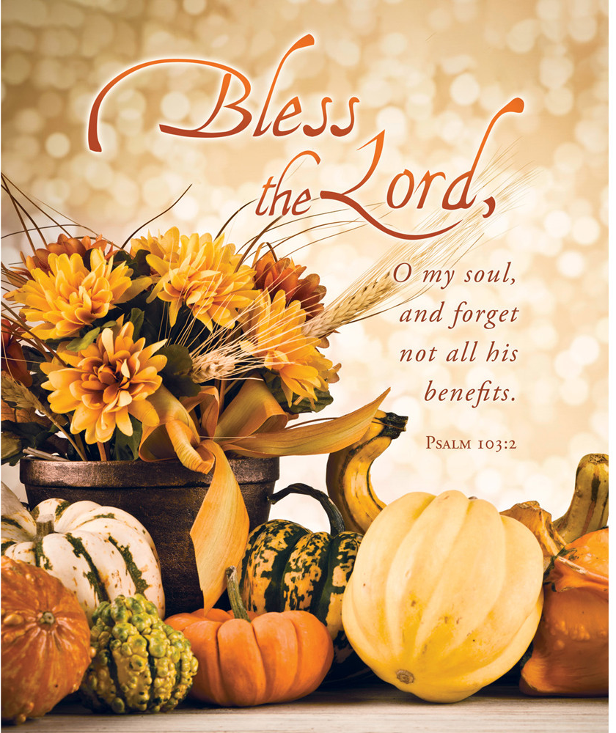

FIRST UNITED METHODIST CHURCH, 301 N JEFFERSON ST, KITTANNING PA Church Phone: 724-548-4312

E-MAIL: fumchurchkittanning@comcast.net WEBSITE: www.firstchurchkittanning.com

PASTOR: Terri Wells CELL PHONE: 814-952-4695 E-MAIL: terriwells53@aol.com CHURCH OFFICE HOURS: Monday – Thursday 8:00-12:00

PASTOR TERRI OFFICE HOURS: Tuesday & Thursday 10:00 AM-4:00 PM

MUSIC VIDEO Come Jesus Come-Stephen McWhirter Worship

MUSICAL PRELUDE

ANNOUNCEMENTS

RINGING OF THE WORSHIP BELL

*CALL TO WORSHIP

Leader: Even though we don’t always feel it, God is with us.

People: The darkness and doubt of the world can threaten to consume us.

Leader: Yet God is with us.

People: All around us, there is fear and hopelessness.

Leader: God brings to us hope and peace. We place our trust in God’s abundant love.

People: Let us freely and without fear open our hearts to God’s healing words of hope. Amen.

OPENING PRAYER
Most Holy and Powerful God, we pray today that you will provide all we need. All we have needed, you have provided. May we know that as we prosper you are the source of our gains, not for our own selfish gain, but for the opportunity to serve you with our gains. For we are blessed to be a blessing! We thank you and we praise you. In the mighty name of Jesus, Amen!

*HYMN “Standin On The Promises of Christ My King” No. 374
JOYS AND CONCERNS/PASTORAL PRAYER/LORD’S PRAYER

ANTHEM “ ”

CHILDREN’S SERMON

*HYMN “O Master, Let Me Walk with Thee” No. 430

SCRIPTURE Luke 20:27-38 N.T. p. 84
Leader: This is the Word of God, for the people of God,
People: Thanks be to God.

SERMON “The Promises of Things to Come”

OFFERING/OFFERTORY/*DOXOLOGY/*PRAYER OF DEDICATION
*Praise God, from whom all blessings flow: praise Him all creatures here below; Praise Him above, ye heavenly host; praise Father, Son and Holy Ghost. Amen.

OFFERING PRAYER
Faithful God, the One who stands with us, may your compassionate care continue to rain down on us. As we bring our offerings, we remember not only what was, but we dare to believe in what will be. You are our strength when we falter, our vision when the future feels uncertain. Use these gifts to rebuild your beloved community—not only in stone and structure, but in lives made whole, and relationships restored. May your peace dwell richly in what we offer and how we live, that the glory of this house-the people called by your name-might truly shine. In Christ’s name we pray. Amen.

*HYMN “When We All Get to Heaven” No. 701

*BENEDICTION
Hear again the promise God made to his people long ago: Do not be discouraged! Be strong and courageous. Keep working, for I am with you. My Spirit remains with you and is living among you. So do not be afraid! Amen.

*Please stand in spirit or in body.
Ask an usher for a large print hymnal or bible or personal hearing device.

EVERYONE IS INVITED TO COME HELP DECORATE THE CHURCH FOR CHRISTMAS. TUESDAY, NOVEMBER 25TH BEGINNING 9:00 AM.

PLEASE NOTE
If anyone would like to offer encouragement and well wishes to Carolyn Hancock on her journey to recovery, you may send cards or notes to Carolyn Hancock, 1301 Carlisle Street, Natrona Heights, PA 15065, Room 284.

NOVEMBER MISSION
Our November and December missions will be to support the food bank at Grace Presbyterian Church. Items that their families value include peanut butter, soup, pasta, tomato sauce, canned fruit, macaroni and cheese, tuna and canned chicken. As always, your financial support is also appreciated. You can leave your donations on the tables in front of the church. Please see Emily with any questions.

MARK YOUR CALENDARS
Mark your calendar now for an Advent event after church on Sunday, December 7, 2025. Plans include lunch and making some Christmas decorations. Details coming soon!

CHILDREN’S CHRISTMAS PLAY
Children’s Christmas play practice will begin Sunday, November 30th during worship. We will present the play during worship on Sunday, December 21st.

YOUTH NEWS
We are adding a mission project to our youth Sunday school program. So, we will be continuing this October’s mission with HAVIN. We will be collecting items for gift bags to be given to the women at the shelter.

On a sad note, we will not be baking pies for Thanksgiving this year. We will be baking cookies for Christmas. Sorry for this news, but maybe another group will pick it up. Melissa B.

NOVEMBER SIFT
The November SIFT Luncheon will be held on Thursday, November 20, 2025 at noon in the Covenant Center. The menu will be Thanksgiving Dinner, Turkey & Stuffing, Mashed Potatoes, Gravy, Corn, Green Beans, Cranberries, Rolls and Butter, Pie. The program will Music with Bruce Shaffer. Reservations can be made from Monday, November 3rd through noon on Monday, November 17th. Please call 724-548-4312. Phone reservations only will be accepted and will be limited to 75. You will need to give a name for each reservation made along with a contact phone number. Please call to cancel as there may be a waiting list. Doors will open at 11:30 AM. Please use the parking lot door. See YOU there!

