FIRST CHURCH WEEKLY CALENDAR
SUNDAY, October 5th
World Communion Sunday
8:45 AM Sunday Bible School
10:00 AM Worship

MONDAY, October 6th
6:00 PM Dart Ball

TUESDAY, October 7th
7:00 PM New Found Freedom-CC

WEDNESDAY, October 8th

Thursday, October 9th

Friday, October 10th

Saturday, October 11th
7:00 PM We Surrender- CC

SUNDAY, October 12th
8:45 AM Sunday School
10:00 AM Worship
2:00 PM Camp 43-CC

THE FLOWERS ON THE ALTAR are presented to the Glory of God in loving memory of our parents, Bob & Jean Schaeffer, given by Sue & Rob Hankey, Audrey Green, Patty Heasley, Bill & Melissa Schaeffer & Brian & Catherine Schaeffer

THANK YOU to the following individuals for assisting with today’s service:
Usher Team: Oxford/Linda VanSicklin
Scripture Reader: Carolyn Hancock
Worship Sound System: Chelsea Beers
Bell Ringer: Cecilia Rearigh
Welcome Center Greeter: Sarah Heckert
Acolyte: Olivia Green
Live Stream: Ray Johnson

OCTOBER newsletters are at the doors.
If anyone would like a newsletter emailed to them, just put your email on your connect card and I will add you to the list.
NOVEMBER NEWSLETTER DEADLINE
SUNDAY, OCTOBER 26, 2025
October 5, 2025

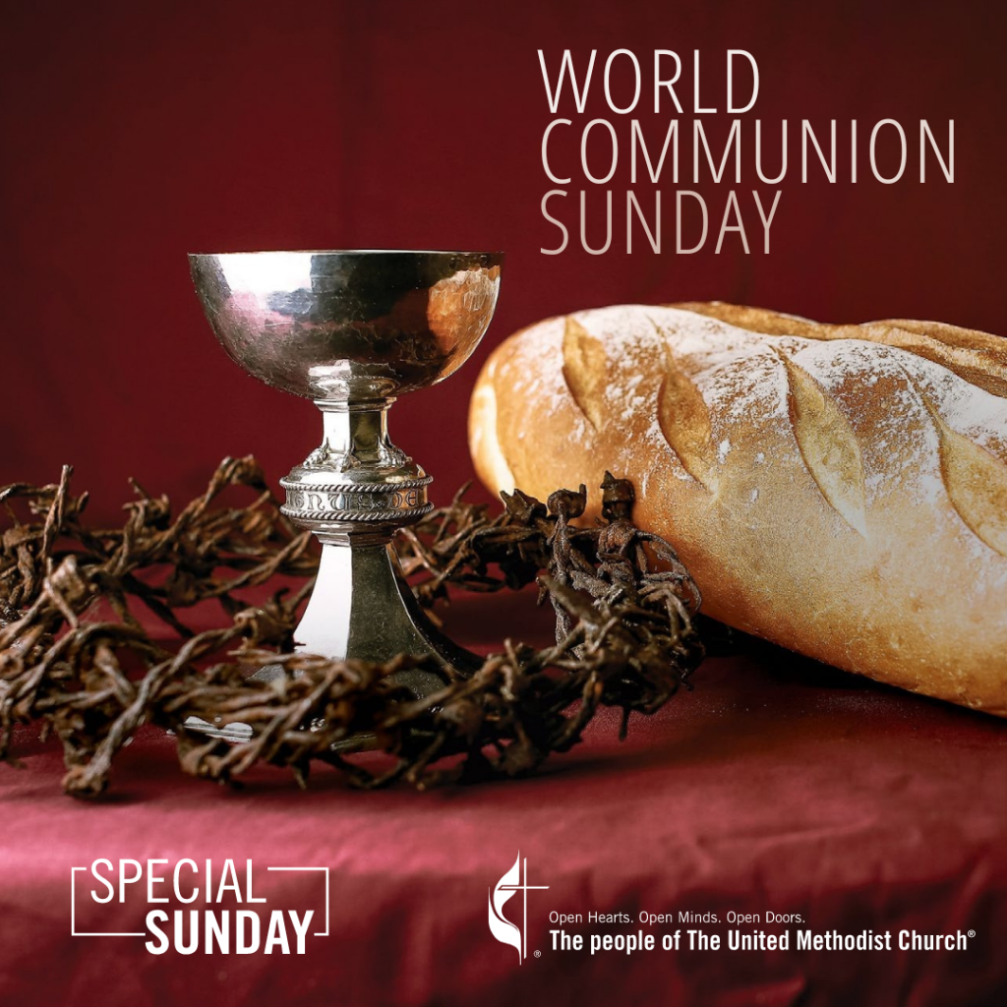

FIRST UNITED METHODIST CHURCH, 301 N JEFFERSON ST, KITTANNING PA Church Phone: 724-548-4312

E-MAIL: fumchurchkittanning@comcast.net WEBSITE: www.firstchurchkittanning.com

PASTOR: Terri Wells CELL PHONE: 814-952-4695 E-MAIL: terriwells53@aol.com CHURCH OFFICE HOURS: Monday – Thursday 8:00-12:00

PASTOR TERRI OFFICE HOURS: Tuesday & Thursday 10:00 AM-4:00 PM

MUSICAL PRELUDE

ANNOUNCEMENTS

RINGING OF THE WORSHIP BELL

*CALL TO WORSHIP

Leader: Destruction and violence are everywhere; strife and contention are all around.

People: the needs of the world are so great; O Lord, increase our faith.

Leader: the law is slack, and justice does not prevail.

People: The needs of the world are so great; O Lord, increase our faith.

Leader: How many threats surround us, warfare, homelessness, loneliness, loss.

People: The needs of the world are so great, but you, O God, are greater still – the One in whom all things are possible. O Lord, increase our faith in you!

OPENING PRAYER
For the gift of faith which sees beyond the present moment and looks to an eternity, we thank you. For the gift of faith small as a mustard seed, which has power within its simplicity, we thank you. For the gift of faith bestowed on those who would simply come, hearts open in humility, we thank you. Amen.

HYMN “God of Grace and God of Glory” No. 577
JOYS AND CONCERNS/PASTORAL PRAYER/LORD’S PRAYER

ANTHEM “In Remembrance of Me”

OFFERING/OFFERTORY/*DOXOLOGY/*PRAYER OF DEDICATION
*Praise God, from whom all blessings flow: praise Him all creatures here below; Praise Him above, ye heavenly host; praise Father, Son and Holy Ghost. Amen.

*HYMN OF PREPARATION “It’s Me, It’s Me, O Lord” No. 352

CHILDREN’S SERMON

SCRIPTURE Lamentations 1:1-6 O.T. p. 762
Leader: This is the Word of God, for the people of God,
People: Thanks be to God.

SERMON “Increase Our Faith”

HOLY COMMUNION No. 12

*HYMN “Let Us Break Bread Together” No. 618

*BENEDICTION

*Please stand in spirit or in body.
Ask an usher for a large print hymnal or bible or personal hearing device.

We thank Vicki Shaeffer for filling in for Pastor Terri today.

CHARGE CONFERENCE
This year’s Charge Conference will be held on Monday, October 13, 2025 here at First Church. Charge SPRC will meet at 6:00 PM. Conference begins at 6:30 PM.
BIG THANK YOU TO ALL WHO SHOWED UP TO CLEAN THE COVENANT CENTER MONDAY, OCTOBER 1ST.

IT IS TIME FOR CHOIR!
If you enjoy singing, please join us at 9:40AM in the library room before church and immediately after church for brief rehearsals. We’d love to have you! Rehearsals start on October 5th.

OCTOBER MISSION
The October mission will be collecting funds to support HAVIN, the domestic abuse shelter in Kittanning. We can also donate gift cards to Walmart, Dollar Tree, Dollar General, Sheetz or Visa cards to help as well. Any questions, please see Emily.

PANCAKE & SAUSAGE DINNER
Tuesday, October 14th at Ford memorial Church in Ford City. Open to the public. Serving times: 11:00-1:00 PM and 4:30-6:30 PM. Dining room service or take-outs can be ordered at 724-763-1540. Adults $10, children under age 10 $5. Sponsored by the churches in the Allegheny River Charge. Benefit: Rainbow Road Preschool at Kittanning First UMC.

HOHO HAPPY HALLOWEEN!
First Church is having a fundraiser for Rainbow Road. Come meet Santa and have your holiday photo taken on October 25, 2025, from Noon to 6:00 PM. A suggested donation of $25.00 will support Rainbow Road. The photos will make great Christmas cards, family gifts, and social media posts. Location: Covenant Center, 332 N Water Street, Kittanning.

OCTOBER SIFT
The October SIFT Luncheon will be held on Thursday, October 16, 2025 at noon in the covenant Center. The menu will be Wedding Soup with crackers, and a Chicken Salad Croissant. Dessert will be a lemon cookie tart. The program will be a travelogue of Italy presented by Donna Lazan. Reservations can be made from Wednesday, October 1st through noon on Monday, September 13th. Please call 724-548-4312. Phone reservations only will be accepted and will be limited to 75. You will need to give a name for each reservation made along with a contact phone number. Please call to cancel as there may be a waiting list. Doors will open at 11:30 AM. Please us the parking lot door. See YOU there!

COMMUNITY OUTREACH PROJECT
ARMSTRONG REHABILITATION AND NURSING CENTER
Would the churches be interested in a community outreach project? Donating items to our Mock Auction. We get Activity Bucks to bid on all kinds of items donated by people for us to use. Items such as body wash, shampoo, socks, sweatpants, sweatshirts, T-shirts, nightgowns, slippers, snacks, pop, hairbrushes, combs, toothbrushes, etc.. It is one of our most favorite activities, topped only by bingo. You can donate collectively as a group-church or individually. Just drop off at the front desk of Armstrong Rehabilitation and Nursing Center- former Health Center (where I now live). 265 South McKean St., Kittanning.
Thanks, Darla
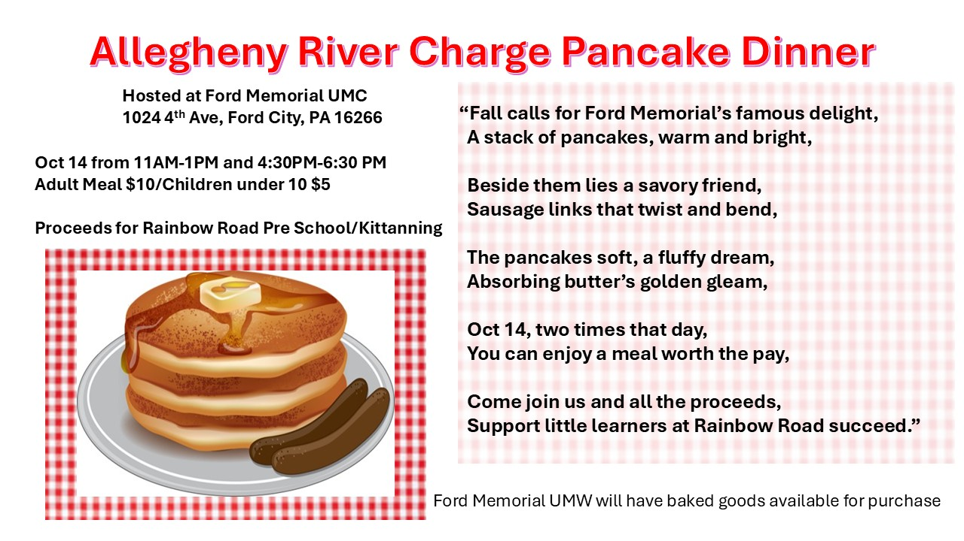

Dear First Church Family,
October is Pastor Appreciation Month. This is a time to show your thanks and appreciation to our pastor. The First church Staffing Team asks that you prayerfully consider celebrating pastor Terri through a monetary gift. We ask that you make y our CASH ONLY gift by Sunday, October 19th.
You may place your gift in the offering plate on Sunday morning, bring it to the church office, or mail you gift to the church at 301 N Jefferson St., Kittanning PA 16201.
We Appreciate Our Pastor!
“How beautiful are the feet of them that preach the Gospel of Peace and bring glad tidings of good things.” Romans 10:15

