
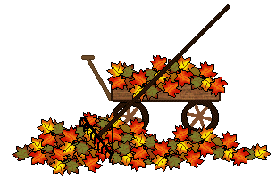

SUNDAY | MONDAY | TUESDAY | WEDNESDAY | THURSDAY | FRIDAY | SATURDAY
 |  |  |   1  9:00 AM Clean Covenant Center | 2 | 3 |   4  7:00 PM We Surrender-CC
5 (G)  9:00 AM Communion (Union)  8:45 AM Sunday Bible School (First)  10:00 AM Communion (First)  11:15 Communion (Ford) |   6 | 7  7:00 PM New Found Freedom-CC | 8 |   9 | 10 |   11  7:00 PM We Surrender-CC
12 (G)  9:00 AM Worship (Union)  8:45 AM Sunday Bible School (First)  10:00 AM Worship (First)  11:15 Worship (Ford)  2:00 PM Camp 43-CC | 13  6:00 PM Charge SPRC  6:30 PM Charge Conference   | 14  1:00 PM Trustees (First)  7:00 PM New Found Freedom-CC |   15 | 16  12:00 PM SIFT Luncheon-CC | 17  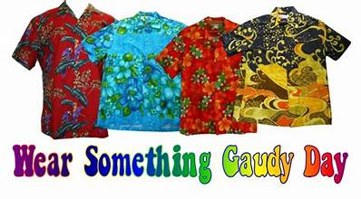 | 18  12:00-6:00 PM Photos With Santa-CC  7:00 PM We Surrender-CC
19 (G)  9:00 AM Worship (Union)  8:45 AM Sunday Bible School (First)  10:00 AM Worship (First)  11:15 AM Worship (Ford) | 20 | 21  7:00 PM Endowment Team (First)  7:00 PM New Found Freedom-CC | 22 | 23 | 24 | 25  7:00 PM We Surrender-CC
26 (G)  9:00 AM Worship (Union)  8:45 AM Sunday Bible School (First)  10:00 AM Worship (First)  11:15 AM Worship (Fiord) | 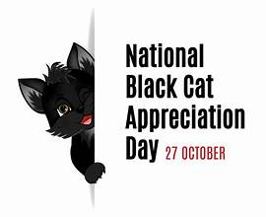  27 | 28  7:00 PM New Found Freedom-CC | 29   | 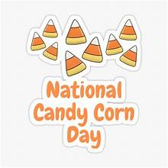  30 |   31

