FIRST CHURCH WEEKLY CALENDAR
SUNDAY, October 26th
8:45 AM Sunday Bible School
10:00 AM Worship
NOVEMBER NEWSLETTER DEADLINE

MONDAY, October 27th
5:00 PM ADK-CC

TUESDAY, October 28th
7:00 PM New Found Freedom-CC

WEDNESDAY, October 29th

Thursday, October 30th

Friday, October 31st

Saturday, November 1st
7:00 PM We Surrender- Church

SUNDAY, November 2nd
ALL SAINTS SUNDAY
8:45 AM Sunday Bible School
10:00 AM Communion

THE FLOWERS ON THE ALTAR are presented to the Glory of God

THANK YOU to the following individuals for assisting with today’s service:
Usher Team: Epworth/Melissa Bureau
Scripture Reader: Dan Wolfe
Worship Sound System: Jeff Hankey
Bell Ringer: Chris Hankey
Welcome Center Greeter: Carolyn Hancock
Acolyte: Caitlyn Kachur
Live Stream: Steph Hankey

OCTOBER newsletters are at the doors.

NOVEMBER NEWSLETTER DEADLINE
SUNDAY, OCTOBER 26, 2025

October 26, 2025
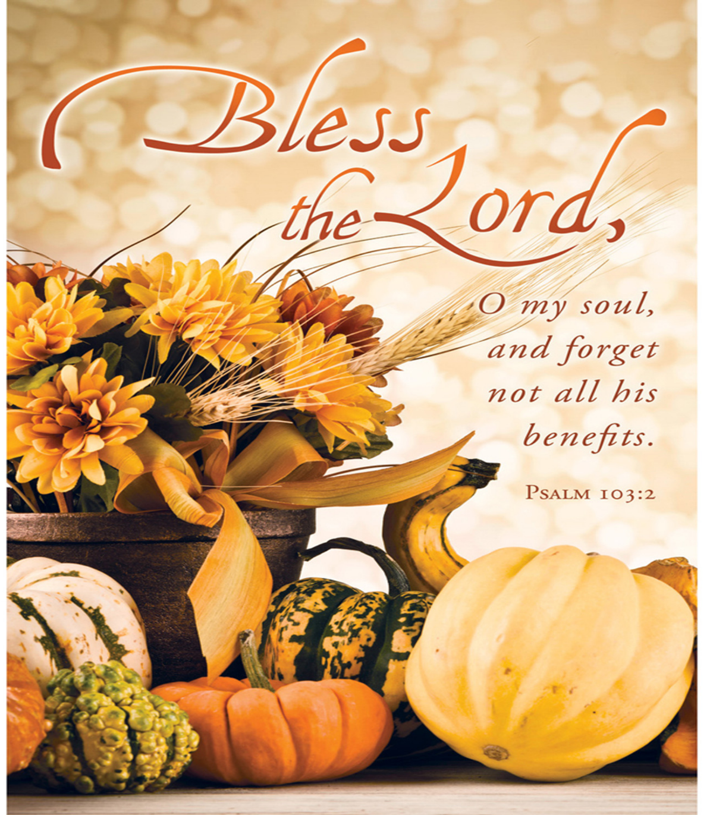

FIRST UNITED METHODIST CHURCH, 301 N JEFFERSON ST, KITTANNING PA Church Phone: 724-548-4312

E-MAIL: fumchurchkittanning@comcast.net WEBSITE: www.firstchurchkittanning.com

PASTOR: Terri Wells CELL PHONE: 814-952-4695 E-MAIL: terriwells53@aol.com CHURCH OFFICE HOURS: Monday – Thursday 8:00-12:00

PASTOR TERRI OFFICE HOURS: Tuesday & Thursday 10:00 AM-4:00 PM

MUSIC VIDEO “24/7 They Humble Me”

MUSICAL PRELUDE

ANNOUNCEMENTS

RINGING OF THE WORSHIP BELL

*CALL TO WORSHIP

Leader: Good and gracious God, you promise to pour out your Spirit upon us; you are the hope of the world.

People: Give us strength, that we might serve you; make us humble, that we might live for your glory alone.

OPENING PRAYER
Lord God in heaven, we confess that we try to measure our faithfulness by comparing ourselves with others. Lord Jesus Christ, have mercy on us as sinners. Forgive us O God where we fail to see your Spirit’s work in others, in those who have lived before us. Lord Jesus Christ, have mercy on us as sinners. Forgive us for choosing comfort and convenience over faithfulness. Lord Jesus Christ, have mercy on us as sinners.

HYMN “O Master, Let Me Walk With Thee” No. 430

JOYS AND CONCERNS/PASTORAL PRAYER/LORD’S PRAYER

CHILDREN’S SERMON

*HYMN “I Am thine, O Lord” No. 419

SCRIPTURE Luke 18:9-14 N.T. p. 81
Leader: This is the Word of God, for the people of God,
People: Thanks be to God.

SERMON “Oh, Lord It’s Hard To Be Humble”

OFFERING/OFFERTORY/*DOXOLOGY/*PRAYER OF DEDICATION
*Praise God, from whom all blessings flow: praise Him all creatures here below; Praise Him above, ye heavenly host; praise Father, Son and Holy Ghost. Amen.

OFFERING PRAYER
Humble and merciful God, you do not require perfection, only a heart that is open. Receive these gifts, not as a sign of our righteousness, but as a humble offering from those who know they need your grace. Teach us again that generosity begins not in pride, but in gratitude—not in proving our worth, but in trusting yours. May what we give today grow into mercy, justice, and joy in the lives of others and in our own. In Jesus’ name, we pray. Amen.

*HYMN “Rock of Ages, Cleft for Me” No. 361

*BENEDICTION
What greater joy can we know that to go home justified because of our humility before God who redeems? Let us leave this place to live as we came in – openly and desiring to praise God and witness to a saving love. Go in humble grace. In Christ’s name. Amen.
*Please stand in spirit or in body.
Ask an usher for a large print hymnal or bible or personal hearing device.
We thank Michael for filling in for Emily today.
OCTOBER MISSION
The October mission will be collecting funds to support HAVIN, the domestic abuse shelter in Kittanning. We can also donate gift cards to Walmart, Dollar Tree, Dollar General, Sheetz or Visa cards to help as well. Any questions, please see Emily.

