
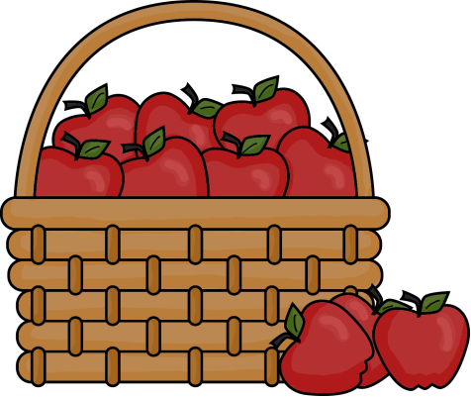
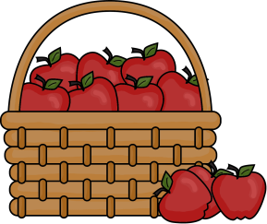

SUNDAY | MONDAY | TUESDAY | WEDNESDAY | THURSDAY | FRIDAY | SATURDAY
 | 1   | 2  1:00 PM Trustees  7:00 PM New Found Freedom-CC |   3 | 4  6:00 PM Bible Study-Ford Memorial  7:00 PM Rainbow Road Parent Meeting |   5 |   6  7:00 PM We Surrender-CC
7 (G)  11:00 AM Charge Picnic-Ingram Park |   8 | 9  9:00-3:00 PM Rainbow Road Open House  7:00 PM Nurture, Outreach & Witness Team (First)  7:00 PM New Found Freedom-CC | 10   | 11  First Day of Rainbow Road  12:00 PM Seniors for Safe Driving-CC | 12   | 13  7:00 PM We Surrender-CC
14 RALLY DAY (G)  8:45 AM Sunday School (First)  9:00 AM Worship (Union)  10:00 AM Worship (First  11:15 AM Worship (Ford)  2:00 PM Camp 43-CC |   15 | 16  8:00 AM Life Line Screenings-CC  6:30 PM Finance (First)  7:00 PM Church Council (First)  7:00 PM New Found Freedom-CC |   17 | 18  12:00 PM SIFT Luncheon -CC  7:00 PM Nominations Team (First) |   19 | 20  9:00 AM Rise Against Hunger Packing-Apollo  7:00 PM We Surrender-CC
21 (G)  8:45 AM Sunday School (First)  9:00 AM Worship (Union)  10:00 AM Worship (First)  11:15 AM Worship (Ford) |   22 | 23  6:00 PM Bible Study-Ford Memorial  7:00 PM New Found Freedom-CC | 24 |   25 |   26 |   27  7:00 PM We Surrender-CC
28  8:45 AM Sunday School (First)  9:00 AM Worship (Union)  10:00 AM Worship (First)  11:15 AM Worship (Ford) |   29 | 30  7:00 PM New Found Freedom-CC

