FIRST CHURCH WEEKLY CALENDAR
SUNDAY, August 24th
10:00 AM Worship

MONDAY, August 25th

TUESDAY, August 26th
6:00 PM Bible Study-Union Ave
7:00 PM New Found Freedom-CC

WEDNESDAY, August 27th

Thursday, August 28th

Friday, August 29th

Saturday, August 30th
7:00 PM We Surrender- CC

SUNDAY, August 31st
10:00 AM Worship

THE FLOWERS ON THE ALTAR are presented to the Glory of God

THANK YOU to the following individuals for assisting with today’s service:
Usher Team: Oxford/Linda VanSicklin
Scripture Reader: Sarah Heckert
Worship Sound System: Tim King
Bell Ringer: Jocelyn King
Welcome Center Greeter: Carolyn Hancock
Acolyte: Hallie Hoffman
Live Stream: Sue Hankey

AUGUST newsletters are at the doors.
If anyone would like a newsletter emailed to them, just put your email on your connect card and I will add you to the list.

SEPTEMBER NEWSLETTER DEADLINE
TODAY--- SUNDAY, AUGUST 24TH
August 24, 2025


FIRST UNITED METHODIST CHURCH, 301 N JEFFERSON ST, KITTANNING PA Church Phone: 724-548-4312

E-MAIL: fumchurchkittanning@comcast.net WEBSITE: www.firstchurchkittanning.com

PASTOR: Terri Wells CELL PHONE: 814-952-4695 E-MAIL: terriwells53@aol.com CHURCH OFFICE HOURS: Monday – Thursday 8:00-12:00

PASTOR TERRI OFFICE HOURS: Tuesday & Thursday 10:00 AM-4:00 PM

MEDIA SONG “We Won’t Be Shaken”

MUSICAL PRELUDE

ANNOUNCEMENTS

RINGING OF THE WORSHIP BELL

*CALL TO WORSHIP

Leader: Children of God, we gather today to encounter God.

People: We do not come expecting to be terrified or dismayed but to be welcomed and embraced.

Leader: We gather today to witness the gospel at work among us.

People: We come to join the assembly of the kingdom of God, to learn to live out God’s kingdom on earth as it is in heaven.

Leader: We gather today to declare our faith in God’s unshakeable kingdom.

People: We come with grateful hearts, trusting in the secure foundation of God’s steadfast love at work among us. Thanks be to God!

OPENING PRAYER
Listening God, hear our prayers as we come before you. Hear the ones who are crying with pain in their heart, heal their pain. Restore their lives. Lead us through the dark valleys. Lead us to our home with you. Teach us to listen to your voice, that we may hear the cry of the needy and respond. Teach us to love. Teach us to lead, with your vision so that we lead others to you. Amen.
HYMN “There’s Something About That Name” (sing twice) No. 171

JOYS AND CONCERNS/PASTORAL PRAYER/LORD’S PRAYER

SPECIAL MUSIC

SCRIPTURE Hebrews 12:18-29 N.T. p. 227
Leader: This is the Word of God, for the people of God,
People: Thanks be to God.

SERMON “A kingdom that will not be shaken”

*HYMN “My Jesus, I Love Thee” No. 172

CHILDREN’S SERMON

OFFERING/OFFERTORY/*DOXOLOGY/*PRAYER OF DEDICATION
*Praise God, from whom all blessings flow: praise Him all creatures here below; Praise Him above, ye heavenly host; praise Father, Son and Holy Ghost. Amen.

OFFERING PRAYER
Unshakable and Holy God, we bring these gifts before you, not as mere offerings, but as acts of faith in your unshakable kingdom. Though the world around us trembles, we trust in your steadfast love, knowing that in Christ, we are welcomed, transformed, and sent forth to serve. Bless these gifts, that they may be used for your will. In Jesus’ name, we pray. Amen.

*HYMN “His Name is Wonderful” (sing twice) No. 174

*BENEDICTIONGo now in the blessing of God’s love that cannot ne shaken, trusting in God’s promises as you work for a world of justice and mercy for all. Amen.
*Please stand in spirit or in body.
Ask an usher for a large print hymnal or bible or personal hearing device.

THANK YOU
Dear Fellow Congregants,
The Trustees are grateful for the assistance provided by all who helped prepare the parsonage project, whether through volunteering time, donating furnishings, or providing monetary support. The parsonage looks outstanding, and we aim to finalize its preparation for occupancy in the next few weeks.

ANNUAL ALL CHARGE PICNIC
Our annual Charge Picnic will be held on Sunday, September 7th. We will meet for Worship at 11 AM at Ingram Park, (452 Troy Hill Road, Kittanning). Worship will include our monthly communion service. Following Worship there will be lunch and fellowship. Main dishes (pulled pork and chicken) will be provided. There will be water provided for a beverage. Please bring a side dish, salad or dessert to share as well as whatever serving utensil is needed. Don’t forget your lawnchair if you don’t want to sit at the picnic tables. Plan to be there! AND PLEASE BE SURE TO MAKE YOUR REGULAR OFFERING FOR THE WEEK TO YOU HOME CHURCH.

SECRETARY POSITION FIRST CHURCH
The First Church Staffing Team is searching for an office secretary. Our new secretary would begin as of January 1, 2026. If you are interested in applying for this position, please visit Indeed.com where the job is posted.

AUGUST MISSION
For August Missions, we will be collecting funds for Rise Against Hunger. We will also need some volunteers from the church to work the packing event on September 20th. There will be more information coming about signing up to work. See Emily with any questions

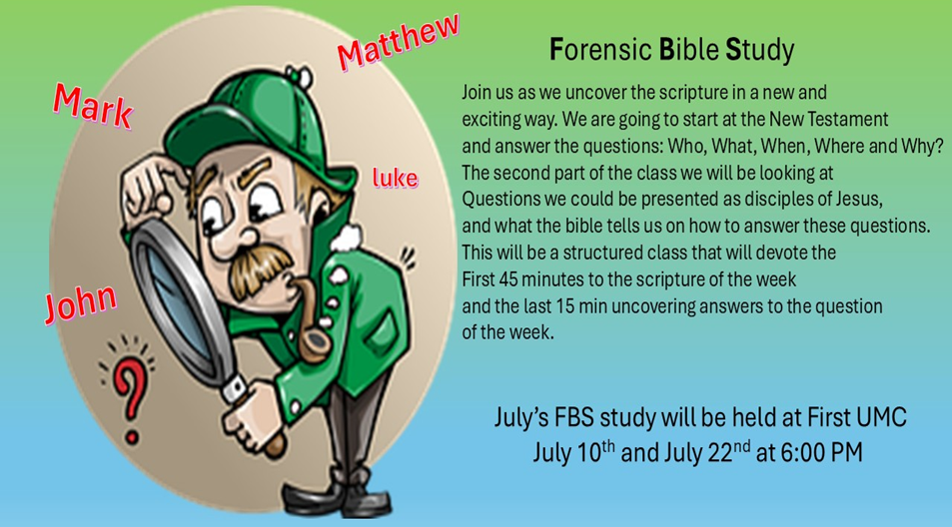

August FBS study will be held at Union Avenue
August 7 & 26th at 6:00 PM

SENIORS IN FELLOWSHIP TOGETHER (SIFT) RETURNS
Our SIFT Luncheons are returning for another year. Our first meeting will be Thursday, September 18, 2025, in the Covenant Center. Doors will open at 11:30, with lunch beginning at Noon. The menu will be Stuffed Green Peppers, Tossed Salad, Italian Bread and Cake for dessert. Phone reservations will be accepted beginning Tuesday, September 2 through Friday, September 12. Names of those attending and a contact phone number will be requested at the time of reservation. Reservations will be limited to 75. Hope to see YOU there!

RAINBOW ROAD CLASSROOM WISH LIST
Household items:
Paper towels, toilet paper, tissues, hand soap, Band-Aids, napkins,
germ-x, 13-gallon kitchen bags, Small paper cups
Toys:
10lbs plastic pellets for sensory table $76.59
Viewmaster Science Viewers (set of 3) $49.99
Magnetic wonder tiles $49.99
Rock n gem surprise $24.99
12 pcs color sorting cups $14.99
Spark create imagine 6 pc animal figures $4.97
Arts and crafts:
Bright splash cardstock $5.88 (x4)
Primary pizzaz cardstock $4.97 (x4)
Colorbok snow white cardstock $4.97
Colorbok black cardstock $4.97
Paint dauberes $19.99
Corrugated cardboard paper sheets red $16.99
Corrugated cardboard paper sheets white $19.49

