FIRST CHURCH WEEKLY CALENDAR
SUNDAY, August 17th
10:00 AM Worship

MONDAY, August 18th

TUESDAY, August 19th
7:00 PM New Found Freedom-CC

WEDNESDAY, August 20th

Thursday, August 21st

Friday, August 22nd

Saturday, August 23rd
7:00 PM We Surrender- CC

SUNDAY, August 24th
10:00 AM Worship

THE FLOWERS ON THE ALTAR are presented to the Glory of God

THANK YOU to the following individuals for assisting with today’s service:
Usher Team: Oxford/Linda VanSicklin
Scripture Reader:
Worship Sound System: Carlee Beers
Bell Ringer: Eliana McGregor
Welcome Center Greeter: Marybeth Dean
Acolyte: Jocelyn King
Live Stream: Brenda Beers

AUGUST newsletters are at the doors.
If anyone would like a newsletter emailed to them, just put your email on your connect card and I will add you to the list.

SEPTEMBER NEWSLETTER DEADLINE
SUNDAY, AUGUST 24TH
August 17, 2025


FIRST UNITED METHODIST CHURCH, 301 N JEFFERSON ST, KITTANNING PA Church Phone: 724-548-4312

E-MAIL: fumchurchkittanning@comcast.net WEBSITE: www.firstchurchkittanning.com

PASTOR: Terri Wells CELL PHONE: 814-952-4695 E-MAIL: terriwells53@aol.com CHURCH OFFICE HOURS: Monday – Thursday 8:00-12:00

PASTOR TERRI OFFICE HOURS: Tuesday & Thursday 10:00 AM-4:00 PM

MEDIA SONG “Am I Worthy” by New Pastures

MUSICAL PRELUDE

ANNOUNCEMENTS

RINGING OF THE WORSHIP BELL

*CALL TO WORSHIP

Leader: Children of God, have you noticed? God has planted seeds of hope among us.

People: We have heard of this hope!

Leader: Have you noticed? God nurtures hope among us, helping us bear the fruit of faithfulness in this world.

People: We seek this hope as we learn to live in faith.

Leader: Have you noticed? The hope of god’s good news forms you to love one another with the love of Christ.

People: We cling to this hope as we grow in love of God, self, neighbor, and all creation.

Leader: Children of God, come! Come, let us worship God who graciously offers us the gift of hope.

People: Come, let us worship God who empowers us to put our hope into faithful and loving actions!

OPENING PRAYER
Gracious and Merciful God, your love is steadfast, and your mercy endures forever. Forgive us for not loving as you love. Forgive us for the ways and words we’ve used to oppress your people and help us to forgive those who’ve oppressed us. Forgive us for the deeds that we’ve encountered. Forgive us for silence during times of injustice and free us to rise and advocate for those who live under the leadership of unjust rulers, who live in a state of turmoil and depression. Help us to reconcile and make peace with one another. Help us to bear one another’s burdens and to be agents of your liberating love so that all of your people will be able to live justly. We confess our sins before you silently now, knowing that you are willing and able to cleanse and revive us through Christ’s resurrecting power, in whose name we pray. Amen.

HYMN “Come, We That Love the Lord” No. 732

JOYS AND CONCERNS/PASTORAL PRAYER/LORD’S PRAYER

SPECIAL MUSIC

OFFERING/OFFERTORY/*DOXOLOGY/*PRAYER OF DEDICATION
*Praise God, from whom all blessings flow: praise Him all creatures here below; Praise Him above, ye heavenly host; praise Father, Son and Holy Ghost. Amen.

HYMN OF PREPARATION “This Is My Song” No. 437

CHILDREN’S SERMON

SCRIPTURE Colossians 1:1-14 N.T. p. 199
Leader: this is the Word of God, for the people of God,
People: Thanks be to God.

SERMON “Making a Difference”
*CLOSING HYMN “God of Grace and God of Glory” No. 577

*BENEDICTION

*Please stand in spirit or in body.
Ask an usher for a large print hymnal or bible or personal hearing device.

We thank Vicki Shaeffer for filling in for Pastor Terri today.

VBS ROAD TRIP MEMORIES & PIZZA PARTY

Join us Thursday, August 14th 5:00-7:30 PM for a VBS Pizza Party for all VBS attendees, both students and staff. We will view some pictures and listen to music as we eat some PIZZA and other snacks. We’ll do a couple of little crafts (some paint will be involved) and play some games as we close out the summer. Then we will quickly set our minds towards the start of the school year and Sunday Bible School. Hope to see you there!

ALTAR FLOWER DATES AVAILABLE IN
AUGUST 24, 31
Arrangements are $35.00. See Audrey if interested.

AUGUST MISSION
For August Missions, we will be collecting funds for Rise Against Hunger. We will also need some volunteers from the church to work the packing event on September 20th. There will be more information coming about signing up to work. See Emily with any questions

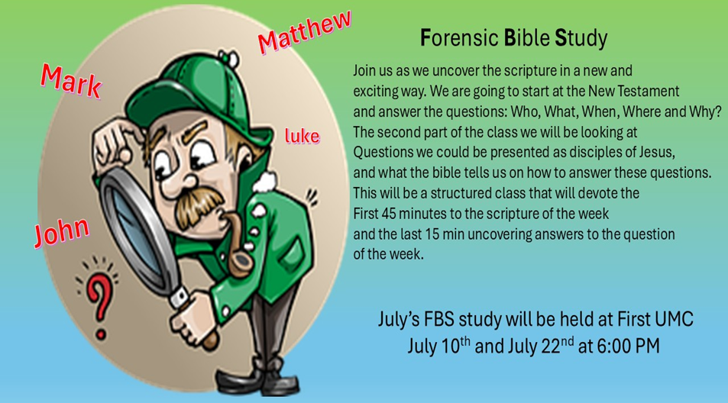

August FBS study will be held at Union Avenue
August 7 & 26th at 6:00 PM

RAINBOW ROAD CLASSROOM WISH LIST
Household items:
Paper towels, toilet paper, tissues, hand soap, Band-Aids, napkins,
germ-x, 13-gallon kitchen bags, Small paper cups
Toys:
10lbs plastic pellets for sensory table $76.59
Viewmaster Science Viewers (set of 3) $49.99
Magnetic wonder tiles $49.99
Rock n gem surprise $24.99
12 pcs color sorting cups $14.99
Spark create imagine 6 pc animal figures $4.97
Arts and crafts:
Bright splash cardstock $5.88 (x4)
Primary pizzaz cardstock $4.97 (x4)
Colorbok snow white cardstock $4.97
Colorbok black cardstock $4.97
Paint dauberes $19.99
Corrugated cardboard paper sheets red $16.99
Corrugated cardboard paper sheets white $19.49

