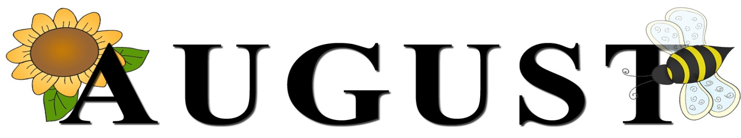

AUGUST 2021
SUNDAY | MONDAY | TUESDAY | WEDNESDAY | THURSDAY | FRIDAY | SATURDAY
 |  |  |  |  | 1  FOLK FESTIVAL | 2  FOLK FESTIVAL  7:00 PM We Surrender- Church
3 FOLK FESTIVAL (G)  9:00 AM Communion (Union)  10:00 AM Communion (First)  11:15 AM Communion (Ford)  5:00 PM Art Show Pictures Out  5:30 PM Clean up from Festival |   4 | 5  6:30 PM FUM Staffing Team (First)  7:00 PM New Found Freedom-CC | 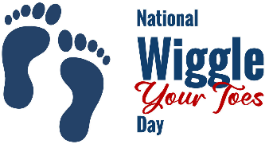  6 | 7  6:00 PM Bible Study at Union Ave | 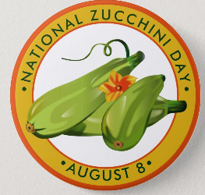  8 | 9  6:00-10:00 PM Robert Dunmire-CC Mission Fundraiser  7:00 PM We Surrender-CC
10 (G)  9:00 AM Worship (Union)  10:00 AM Worship (First)  11:15 AM Worship (Ford)  2:00 PM Camp 43-CC | 11  6:00 PM Dart Ball Open House | 12  7:00 PM New Found Freedom-CC | 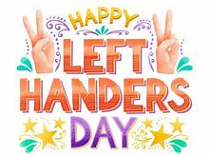  13 |   14  5:00-7:30 PM VBS Road Trip Memories-CC | 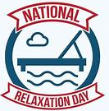  15 | 16  7:00 PM We Surrender-CC
17 (G)  9:00 AM Worship (Union)  10:00 AM Worship (First)  11:15 AM Worship (Ford) | 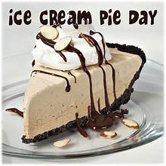  18 | 19  7:00 PM New Found Freedom-CC | 20  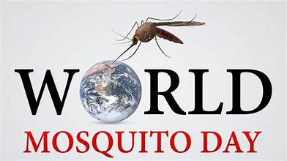 | 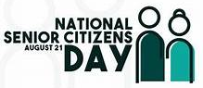  21 | 22 | 23  7:00 PM We Surrender-CC
24 (G)  9:00 AM Worship (Union)  10:00 AM Worship (First)  11:15 AM Worship (Ford) | 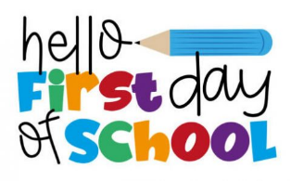  25 | 26  6:00 PM Bible Study at Union Ave  7:00 PM New Found Freedom-CC | 27 | 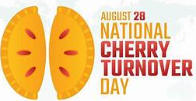  28 | 29 | 30  7:00 PM We Surrender-CC
31 (G)

9:00 AM Worship (Union)
10:00 AM Worship (First)
11:15 AM Worship (Ford)

