FIRST CHURCH WEEKLY CALENDAR
SUNDAY, August 10th
10:00 AM Worship
2:00 PM Camp 43-CC

MONDAY, August 11th
6:00 PM Dart Ball Open House

TUESDAY, August 12th
7:00 PM New Found Freedom-CC

WEDNESDAY, August 13th

Thursday, August 14th
5:00 PM VBS Road Trip Memories-CC

Friday, August 15th

Saturday, August 16th
7:00 PM We Surrender- CC

SUNDAY, August 17th
10:00 AM Worship

THE FLOWERS ON THE ALTAR are presented to the Glory of God

THANK YOU to the following individuals for assisting with today’s service:
Usher Team: Epworth/Melissa Bureau
Scripture Reader: Sue Hankey
Worship Sound System: Chelsea Beers
Bell Ringer: Emersyn McGregor
Welcome Center Greeter: Melissa Bureau
Acolyte: Chris Hankey
Live Stream: Ray Johnson

AUGUST newsletters are at the doors.
If anyone would like a newsletter emailed to them, just put your email on your connect card and I will add you to the list.

SEPTEMBER NEWSLETTER DEADLINE
SUNDAY, AUGUST 24TH
August 10, 2025
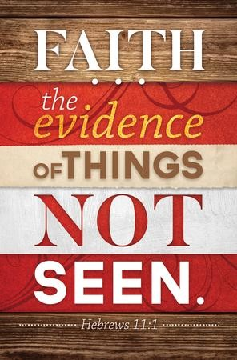

FIRST UNITED METHODIST CHURCH, 301 N JEFFERSON ST, KITTANNING PA Church Phone: 724-548-4312

E-MAIL: fumchurchkittanning@comcast.net WEBSITE: www.firstchurchkittanning.com

PASTOR: Terri Wells CELL PHONE: 814-952-4695 E-MAIL: terriwells53@aol.com CHURCH OFFICE HOURS: Monday – Thursday 8:00-12:00

PASTOR TERRI OFFICE HOURS: Tuesday & Thursday 10:00 AM-4:00 PM

MEDIA SONG “More Like Jesus” by One Voice Worship

MUSICAL PRELUDE

ANNOUNCEMENTS

RINGING OF THE WORSHIP BELL

*CALL TO WORSHIP

Leader: Beloved, we gather today as inheritors of faith in God’s work, a faith handed down to us over generations that we claim and proclaim today in this community.

People: By faith, we follow God’s call as we journey toward a better country.

Leader: By faith, our grandparents, parents, aunts, uncles, neighbors, and friends shared God’s love with us, a love that longs to draw us all as members of the Body of Christ.

People: By faith, we follow God’s call as we journey toward a better country.

Leader: By faith, we remember the story today, the story of God’s desire for all creation to be reconciled to God and one another.

People: By faith, we follow God’s call as we journey toward a better country.

Leader: By faith we carry the faith forward, building a community of belonging, provision, and care as we journey with God toward a better country.

People: By faith, we gather to nourish and encourage one another on the journey toward a better country as we build God’s already-but-not-yet kingdom here and now. Amen.

OPENING PRAYER
Now faith is the assurance of things hoped for, the conviction of things not seen. We come convinced of many things but trusting very few. Holy God of limitless surprises, meet us here in this place as we touch that which we cannot see, that which we have not dared to hope. Amen.

HYMN “Faith of Our Fathers” No. 710

JOYS AND CONCERNS/PASTORAL PRAYER/LORD’S PRAYER

SPECIAL MUSIC

SCRIPTURE Hebrews 11:1-3, 8-16 N.T. p. 225
Leader: this is the Word of God, for the people of God,
People: Thanks be to God.

SERMON “Looking For More”

CHILDREN’S SERMON

HYMN “Take Time to Be Holy” No. 395

OFFERING/OFFERTORY/*DOXOLOGY/*PRAYER OF DEDICATION
*Praise God, from whom all blessings flow: praise Him all creatures here below; Praise Him above, ye heavenly host; praise Father, Son and Holy Ghost. Amen.

OFFERING PRAYER
Faithful and Gracious God, you have called us to be a people of hope, to trust in what we cannot see. As we bring these gifts before you, we offer not only our resources but also our faith—faith that you are at work in our giving, building a future of justice, mercy, and love. Bless these offerings, that they may be signs of our longing for your kingdom and our trust in your promises. May our generosity inspire others to live with courage and conviction, seeking that better country you have prepared for us. In Christ’s name, we pray. Amen.

*HYMN “We Are The Church” No. 558

*BENEDICTION
Children of God, by faith, God has brought us this far. Go now in the blessing of the God who goes before you and behind you, surrounding you on all sides with grace as we journey toward a better country in our neighborhood, our community, and beyond. Amen.

*Please stand in spirit or in body.
Ask an usher for a large print hymnal or bible or personal hearing device.

VBS ROAD TRIP MEMORIES & PIZZA PARTY

Join us Thursday, August 14th 5:00-7:30 PM for a VBS Pizza Party for all VBS attendees, both students and staff. We will view some pictures and listen to music as we eat some PIZZA and other snacks. We’ll do a couple of little crafts (some paint will be involved) and play some games as we close out the summer. Then we will quickly set our minds towards the start of the school year and Sunday Bible School. Hope to see you there!

ALTAR FLOWER DATES AVAILABLE IN
AUGUST 24, 31
Arrangements are $35.00. See Audrey if interested.
AUGUST MISSION
For August Missions, we will be collecting funds for Rise Against Hunger. We will also need some volunteers from the church to work the packing event on September 20th. There will be more information coming about signing up to work. See Emily with any questions

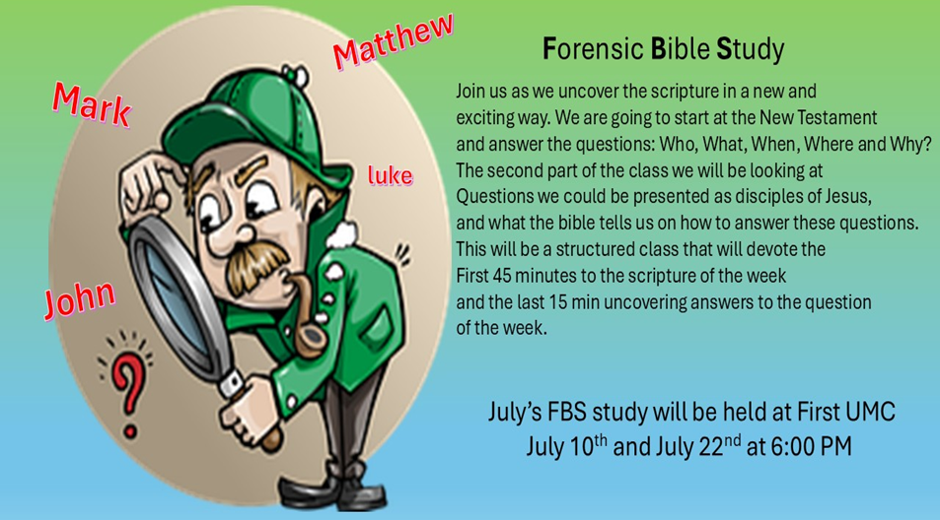

August FBS study will be held at Union Avenue
August 7 & 26th at 6:00 PM

FRIENDS HELPING FRIENDS
Hello “Friends”! Your friends at Rainbow Road have joined with Boscov’s to bring you, our “friends”, a great savings opportunity. For a donation of $5 we will give you a coupon for 25% off your purchases at the store. The coupon is only good in store on October 22, 2025. Please contact “your friend” Ray Johnson, for your Friends Helping Friends coupon supporting Rainbow Road! Phone 951-965-2121 email: u21sob@gmail.com

RAINBOW ROAD CLASSROOM WISH LIST
Household items:
Paper towels, toilet paper, tissues, hand soap, Band-Aids, napkins,
germ-x, 13-gallon kitchen bags, Small paper cups
Toys:
10lbs plastic pellets for sensory table $76.59
Viewmaster Science Viewers (set of 3) $49.99
Magnetic wonder tiles $49.99
Rock n gem surprise $24.99
12 pcs color sorting cups $14.99
Spark create imagine 6 pc animal figures $4.97
Arts and crafts:
Bright splash cardstock $5.88 (x4)
Primary pizzaz cardstock $4.97 (x4)
Colorbok snow white cardstock $4.97
Colorbok black cardstock $4.97
Paint dauberes $19.99
Corrugated cardboard paper sheets red $16.99
Corrugated cardboard paper sheets white $19.49

