FIRST CHURCH WEEKLY CALENDAR
SUNDAY, August 3rd
Folk Festival
10:00 AM Communion
5:00 PM Art Show Pictures Out
6:30 PM Tear Down Festival

MONDAY, August 4th

TUESDAY, August 5th
6:30 PM FUMC Staffing Team
7:00 PM New Found Freedom-Church

WEDNESDAY, August 6th

Thursday, August 7th
6:00 PM Bible Study-Union Ave

Friday, August 8th

Saturday, August 9th
6:00-10:00 PM Robert Dunmire-CC
7:00 PM We Surrender- Church

SUNDAY, August 10th
10:00 AM Worship
2:00 PM Camp 43-CC

THE FLOWERS ON THE ALTAR are presented to the Glory of God

THANK YOU to the following individuals for assisting with today’s service:
Usher Team: Epworth/Melissa Bureau
Scripture Reader: Melissa Bureau
Worship Sound System: Jeff Hankey
Bell Ringer: Chris Hankey
Welcome Center Greeter: Sarah Heckert
Acolyte: Caitlyn Kachur
Live Stream: Brenda Beers

AUGUST newsletters are at the doors.
If anyone would like a newsletter emailed to them, just put your email on your connect card and I will add you to the list.

August 3, 2025
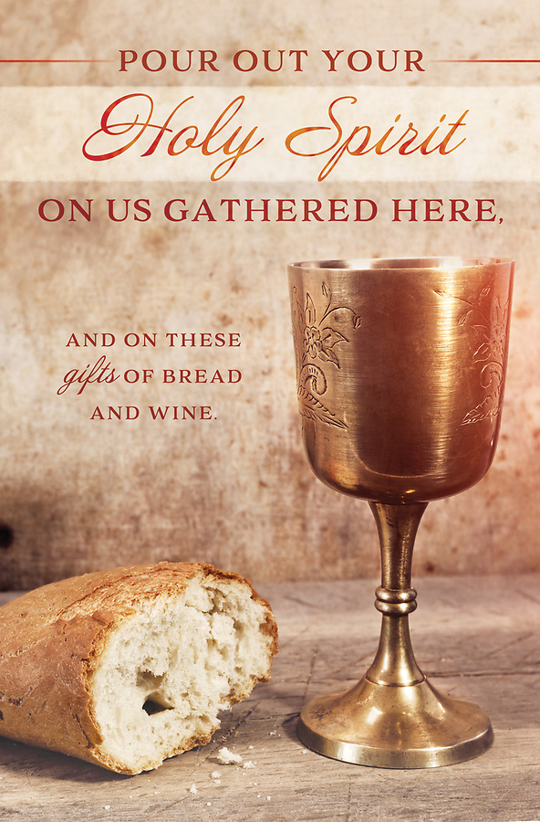

FIRST UNITED METHODIST CHURCH, 301 N JEFFERSON ST, KITTANNING PA Church Phone: 724-548-4312

E-MAIL: fumchurchkittanning@comcast.net WEBSITE: www.firstchurchkittanning.com

PASTOR: Terri Wells CELL PHONE: 814-952-4695 E-MAIL: terriwells53@aol.com CHURCH OFFICE HOURS: Monday – Thursday 8:00-12:00

PASTOR TERRI OFFICE HOURS: Tuesday & Thursday 10:00 AM-4:00 PM

MEDIA SONG Higher Ground (I’m Pressing on the Upward Way)

MUSICAL PRELUDE

ANNOUNCEMENTS

RINGING OF THE WORSHIP BELL

*CALL TO WORSHIP

Leader: Children of God, we gather as people who have received new life in Jesus Christ.

People: We come to set our minds on Christ, who surrounds us in love.

Leader: The world tries to distract us with anxious rumors, worrisome lies, and misleading half-truths.

People: We come to set our minds on Christ, who surrounds us in love.

Leader: In this place, we gather to remind, remember, and renew our commitment to dwell in the love of Christ.

People: We come to set our minds on Christ, who surrounds us in love.

Leader: Children of God, come! Let us worship God, who clothes us in new life and renews us in grace.

People: Come, let us worship as we set our minds on Christ, who surrounds us in love.

OPENING PRAYER
God, our guide and our protector, as we gather today in your holy house, open our minds and souls and hearts, that we may be inclined to hear the gentle direction of your Spirit in our lives. Help us follow you as you lead us to the land you have created for us, where we may dwell with you and in you. Amen.

HYMN “I Am Thine, O Lord” No. 419

JOYS AND CONCERNS/PASTORAL PRAYER/LORD’S PRAYER

SPECIAL MUSIC

SCRIPTURE Colossians 3:1-11 N.T. p. 198
Leader: this is the Word of God, for the people of God,
People: Thanks be to God.

SERMON “Setting Our Minds on Higher Ground”

COMMUNION

CHILDREN’S SERMON

OFFERING/OFFERTORY/*DOXOLOGY/*PRAYER OF DEDICATION
*Praise God, from whom all blessings flow: praise Him all creatures here below; Praise Him above, ye heavenly host; praise Father, Son and Holy Ghost. Amen.

OFFERING PRAYER
Holy and ever-present God, you call us to set our minds on things above, to let go of all that weighs us down, and to embrace the new life found in Christ. As we bring these gifts, shape our hearts in generosity, our hands in service, and our minds in faithfulness. May these offerings be used to transform lives, to build up your kingdom, and to reflect your love in this
world. Keep us ever mindful that we give because you have first given so abundantly to us. In Christ’s name, we pray. Amen.

*HYMN “Breathe on Me, Breath of God” No. 420

*BENEDICTION
Children of God, receive this blessing: may the renewing grace of the Triune God surround you; may the steadfast love of the Triune God uphold you, and may the goodness of the triune God entice you to set your mind on Christ that you may live as God’s image-bearers and gospel-bringers wherever you go. Amen.

*Please stand in spirit or in body.
Ask an usher for a large print hymnal or bible or personal hearing device.

We extend our Christian Compassion and concern to Tim Scaife and his family on the death of his wife, Linda Scaife. Linda passed away on Friday, July 25, 2025. She was the mother to Emily (Tim) King and Erica (Jim) Scaife Deaton. Linda was the grandmother to Caden and Jocelyn King. She will be missed.

VBS ROAD TRIP MEMORIES & PIZZA PARTY

Join us Thursday, August 14th 5:00-7:30 PM for a VBS Pizza Party for all VBS attendees, both students and staff. We will view some pictures and listen to music as we eat some PIZZA and other snacks. We’ll do a couple of little crafts (some paint will be involved) and play some games as we close out the summer. Then we will quickly set our minds towards the start of the school year and Sunday Bible School. Hope to see you there!

ALTAR FLOWER DATES AVAILABLE IN
AUGUST 10, 17, 24, 31
Arrangements are $35.00. See Audrey if interested.
AUGUST MISSION
For August Missions, we will be collecting funds for Rise Against Hunger. We will also need some volunteers from the church to work the packing event on September 20th. There will be more information coming on signing up to work. See Emily with any questions

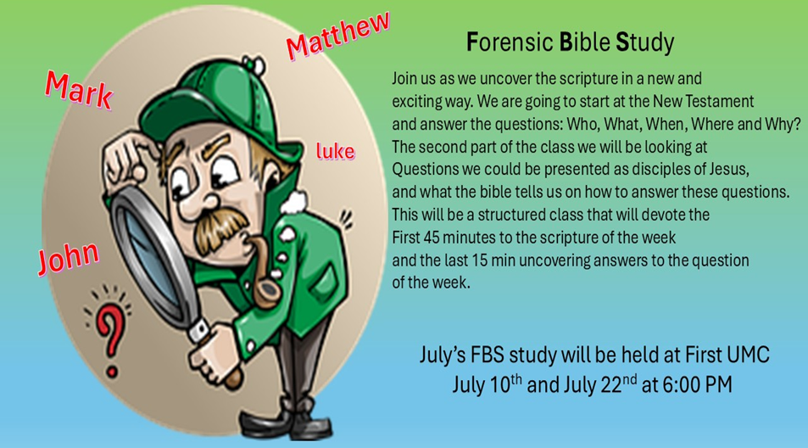

August FBS study will be held at Union Avenue
August 7 & 26th at 6:00 PM

FRIENDS HELPING FRIENDS
Hello “Friends”! Your friends at Rainbow Road have joined with Boscov’s to bring you, our “friends”, a great savings opportunity. For a donation of $5 we will give you a coupon for 25% off your purchases at the store. The coupon is only good in store on October 22, 2025. Please contact “your friend” Ray Johnson, for your Friends Helping Friends coupon supporting Rainbow Road! Phone 951-965-2121 email: u21sob@gmail.com

RAINBOW ROAD CLASSROOM WISH LIST
Household items:
Paper towels, toilet paper, tissues, hand soap, Band-Aids, napkins,
germ-x, 13 gallon kitchen bags, Small paper cups
Toys:
10lbs plastic pellets for sensory table $76.59
Viewmaster Science Viewers (set of 3) $49.99
Magnetic wonder tiles $49.99
Rock n gem surprise $24.99
12 pcs color sorting cups $14.99
Spark create imagine 6 pc animal figures $4.97
Arts and crafts:
Bright splash cardstock $5.88 (x4)
Primary pizzaz cardstock $4.97 (x4)
Colorbok snow white cardstock $4.97
Colorbok black cardstock $4.97
Paint dauberes $19.99
Corrugated cardboard paper sheets red $16.99
Corrugated cardboard paper sheets white $19.49

