FIRST CHURCH WEEKLY CALENDAR
SUNDAY, July 27th
10:00 AM Worship
11:30 PM Art Show Pictures In-CC

MONDAY, July 28th

TUESDAY, July 29th
7:00 PM New Found Freedom-Church

WEDNESDAY, July 30th
6:00 PM Artists Meet & Greet-CC

THURSDAY, July 31st
Folk Festival

FRIDAY, August 1st
Folk Festival

SATURDAY, August 2nd
Folk Festival
7:00 PM We Surrender- Church

SUNDAY, August 3rd
10:00 AM Worship
Folk Festival
5:00-6:00 PM Art Show Pictures Out
6:30 PM Tear Down Folk Festival

THE FLOWERS ON THE ALTAR are presented to the Glory of God in honor of Joe Heckert’s 83rd birthday, given by Sarah Heckert

THANK YOU to the following individuals for assisting with today’s service:
Usher Team: Asbury/Donna Lazan
Scripture Reader: Sarah Heckert
Worship Sound System: Jeff Hankey
Bell Ringer: Jocelyn King
Welcome Center Greeter: Carolyn Hancock
Acolyte: Caden King
Live Stream: Sue Hankey

AUGUST newsletters are at the doors.
If anyone would like a newsletter emailed to them, just put your email on your connect card and I will add you to the list.

We thank Janice Bernot for filling in for Emily today.
July 27, 2025


FIRST UNITED METHODIST CHURCH, 301 N JEFFERSON ST, KITTANNING PA Church Phone: 724-548-4312

E-MAIL: fumchurchkittanning@comcast.net WEBSITE: www.firstchurchkittanning.com

PASTOR: Terri Wells CELL PHONE: 814-952-4695 E-MAIL: terriwells53@aol.com CHURCH OFFICE HOURS: Monday – Thursday 8:00-12:00

PASTOR TERRI OFFICE HOURS: Tuesday & Thursday 10:00 AM-4:00 PM

MEDIA SONG “Have a Little Talk with Jesus” Backwoods Bluegrass

MUSICAL PRELUDE

ANNOUNCEMENTS

RINGING OF THE WORSHIP BELL

*CALL TO WORSHIP

Leader: Children of God, when the journey ahead seems long and hard, full of unknown dangers and all-too-real risks, remember:

People: Keep the faith. God, who made us alive, is our Guardian and Guide.

Leader: When the voices on the side of the road tempt us with their misinformation full of unearned certainty, simple solutions, and quickness to blame and shame those who disagree with them, remember:

People: Stay the course. God, who made us alive, is our Wisdom and Judge.

Leader: When those in power place barriers in our way, making it harder to share the love of God in our communities, trying to convince us it is easier to do nothing than remain firm in God’s call to act for the flourishing of all our neighbors, remember:

People: Do not be afraid. God, who made us alive, is our Strength and our Advocate.

Leader: Children of God, come! Let us worship God, whose persistent love empowers us to persevere, to stay the course, to live by faith and not fear.
People: Come, let us worship God, who makes us alive, through grace to love and serve God and one another.

OPENING PRAYER
God, we share your grief at the discord that rages among your children, the rejection of those who bear your image, and the oppression of those you know by name. We turn toward you for strength and guidance to turn away from the norms of this world, the lure of self-righteousness, and the appeal of comfort over justice. Embolden us to believe that another world is possible and empower us to participate in its creation. Amen.

HYMN “Crown Him with Many Crowns” No. 327

JOYS AND CONCERNS/PASTORAL PRAYER/LORD’S PRAYER

SCRIPTURE Colossians 2:6-9 N.T. p. 200
Leader: this is the Word of God, for the people of God,
People: Thanks be to God.

SERMON “Stay Alive and on course”

*HYMN “O Master, Let Me Walk With Thee” No. 430

CHILDREN’S SERMON

OFFERING/OFFERTORY/*DOXOLOGY/*PRAYER OF DEDICATION
*Praise God, from whom all blessings flow: praise Him all creatures here below; Praise Him above, ye heavenly host; praise Father, Son and Holy Ghost. Amen.

OFFERING PRAYER
Loving God, in Christ, you have made us fully alive, setting us free from all that would hold us captive. As we bring these gifts, we do so in

gratitude, abounding in thanksgiving for your grace. May these offerings be signs that we are rooted in you, bearing fruit for your kingdom. Let them be used to bring hope, healing, and new life to those in need. Keep us steadfast in Christ, walking in faith and filled with the joy of your transforming love. In the name of the one who makes us whole, we pray. Amen.

*HYMN “Close to Thee” No. 407

*BENEDICTION
Go now in the blessing and power of God who gives us life, that you may grow in faith and live as bearers of love and life everywhere you go. Amen.

*Please stand in spirit or in body.
Ask an usher for a large print hymnal or bible or personal hearing device.
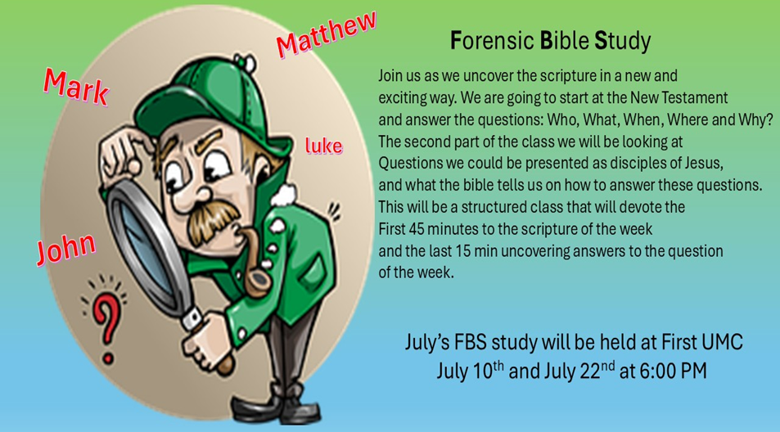
VBS ROAD TRIP MEMORIES & PIZZA PARTY

Join us Thursday, August 14th 5:00-7:30 PM for a VBS Pizza Party for all VBS attendees, both students and staff. We will view some pictures and listen to music as we eat some PIZZA and other snacks. We’ll do a couple of little crafts (some paint will be involved) and play some games as we close out the summer. Then we will quickly set our minds towards the start of the school year and Sunday Bible School. Hope to see you there!

JULY MISSION
For July and August Missions, we will be collecting funds for Rise Against Hunger. We will also need some volunteers from the church to work the packing event on September 20th. There will be more information coming on signing up to work. See Emily with any questions

ALTAR FLOWER DATES AVAILABLE IN
AUGUST 3, 10, 17, 24, 31
Arrangements are $35.00. See Audrey if interested.

August FBS study will be held at Union Avenue
August 7 & 26th at 6:00 PM

FRIENDS HELPING FRIENDS
Hello “Friends”! Your friends at Rainbow Road have joined with Boscov’s to bring you, our “friends”, a great savings opportunity. For a donation of $5 we will give you a coupon for 25% off your purchases at the store. The coupon is only good in store on October 22, 2025. Please contact “your friend” Ray Johnson, for your Friends Helping Friends coupon supporting Rainbow Road! Phone 951-965-2121 email: u21sob@gmail.com

HELP NEEDED FOR FOLK FESTIVAL
Time to sign-up to help with the Festival. Sign-up is in the front of the church. Festival schedule is Thursday July 31, 5:00-10:00PM, Friday, August 1, 12:00-10:00PM, Saturday, August 2, 12:00-10:00PM and Sunday, August 3, 12:00-6:00PM.
Help is needed for the First Church food booth as outlined below. Please help when you can, where you can and as often as possible.
Saturday, July 26 from 9:00-12:00-Help is needed to set up the booth and tent for the festival. This takes many, so all are welcome, no need to sign up.
Booth workers needed: please call Melissa Bureau (724-859-2607) to schedule a time to work in the booth or watch for the schedule at a church service.
Thursday, July 31, 9:00-11:30 AM need help to set up tables and
chairs outside, move refrigerators, freezers and other equipment to booth.
Thursday-Saturday festival evening cleanup- starting about 9:30PM-carry items from booth inside, clean booth and tables, wash all dirty containers and utensils, empty garbage cans…
Sunday Evening Clean up—Many people will be needed to clean up and put away after the festival ends at 6:00 PM on Sunday, August 4th. No need to sign up. Everyone is welcome. Will do some cleanup starting at 5:30 PM.
Please make sure you SIGN IN any time you are working. Thank you. Tim Scaife, Activities Chairman 724-664-5346

RAINBOW ROAD CLASSROOM WISH LIST
Household items:
Paper towels, toilet paper, tissues, hand soap, Band-Aids, napkins,
germ-x, 13 gallon kitchen bags, Small paper cups
Toys:
10lbs plastic pellets for sensory table $76.59
Viewmaster Science Viewers (set of 3) $49.99
Magnetic wonder tiles $49.99
Rock n gem surprise $24.99
12 pcs color sorting cups $14.99
Spark create imagine 6 pc animal figures $4.97
Arts and crafts:
Bright splash cardstock $5.88 (x4)
Primary pizzaz cardstock $4.97 (x4)
Colorbok snow white cardstock $4.97
Colorbok black cardstock $4.97
Paint dauberes $19.99
Corrugated cardboard paper sheets red $16.99
Corrugated cardboard paper sheets white $19.49

