FIRST CHURCH WEEKLY CALENDAR
SUNDAY, July 13th
10:00 AM Worship
2:00 PM Camp 43-CC

MONDAY, July 14th

TUESDAY, July 15th
6:30 PM Finance
7:00 PM Church Council
7:00 PM New Found Freedom-CC

WEDNESDAY, July 16th

THURSDAY, July 17th
6:00 PM Bible Study at First Church

FRIDAY, July 18th

SATURDAY, July 19th
7:00 PM We Surrender- CC

SUNDAY, July 20th
10:00 AM Worship

THE FLOWERS ON THE ALTAR are presented to the Glory of God

THANK YOU to the following individuals for assisting with today’s service:
Usher Team: Oxford/Linda VanSicklin
Scripture Reader:
Worship Sound System: Chelsea Beers
Bell Ringer: Chris Hankey
Welcome Center Greeter: Melissa Bureau
Acolyte: Jocelyn King
Live Stream: Ray Johnson

JULY newsletters are at the doors.
If anyone would like a newsletter emailed to them, just put your email on your connect card and I will add you to the list.

AUGUST NEWSLETTER DEADLINE-SUNDAY, JULY 20TH
July 13, 2025


FIRST UNITED METHODIST CHURCH, 301 N JEFFERSON ST, KITTANNING PA Church Phone: 724-548-4312

E-MAIL: fumchurchkittanning@comcast.net WEBSITE: www.firstchurchkittanning.com

PASTOR: Terri Wells CELL PHONE: 814-952-4695 E-MAIL: terriwells53@aol.com CHURCH OFFICE HOURS: Monday – Thursday 8:00-12:00

PASTOR TERRI OFFICE HOURS: Tuesday & Thursday 10:00 AM-4:00 PM

MEDIA SONG “Christ Our Hope in Life and Death”

MUSICAL PRELUDE

ANNOUNCEMENTS

RINGING OF THE WORSHIP BELL

*CALL TO WORSHIP

Leader: Children of God, are you listening? Have you noticed? God has planted seeds of hope among us.

People: We have heard of this hope!

Leader: Are you listening? Have you noticed? God nurtures hope among us, helping us bear the fruit of faithfulness in this world.

People: We seek this hope as we learn to live in faith.

Leader: Are you listening? Have you noticed? The hope of God’s good news forms you to love one another with the love of Christ.

People: We cling to this hope as we grow in love of God, self, neighbor, and all creation.

Leader: Children of God, come! Come, let us worship God who graciously offers us the gift of hope.

People: Come, let us worship God who empowers us to put our hope into faithful and loving actions!

OPENING PRAYER
Holy God, we come together to worship, with all our hearts and souls, and with all our might. We really do want to listen to your voice above all of the other voices in our lives. But we get bogged down in the daily routine. We forget who we are. We forget who you are. We forget what the church is supposed to be. So here we are, gathered before you today, asking that you would make yourself known to us, that you would help us to recognize the presence of the Holy Spirit and make us into the people you want us to be. Amen.

HYMN “Come thou Fount of Every Blessing” No. 400

JOYS AND CONCERNS/PASTORAL PRAYER/LORD’S PRAYER

SPECIAL MUSIC

SCRIPTURE Colossians 1:1-14 N.T. p. 199
Leader: this is the Word of God, for the people of God,
People: Thanks be to God.

SERMON “Living in hope”

*HYMN “Rise Up, O Men of God” No. 576

CHILDREN’S SERMON

OFFERING/OFFERTORY/*DOXOLOGY/*PRAYER OF DEDICATION
*Praise God, from whom all blessings flow: praise Him all creatures here below; Praise Him above, ye heavenly host; praise Father, Son and Holy Ghost. Amen.

OFFERING PRAYER
Gracious God, in you, we find the power to endure with patience and the grace to give thanks with joy. As we offer these gifts, may they bear fruit
in your kingdom, strengthening the church, uplifting the weary, and sharing the hope we have in Christ. Help us remember that we are not alone but surrounded by the saints of light, past and present. May our generosity reflect your abundant love and our lives proclaim the gospel in word and deed. In Christ’s name, we give and rejoice. Amen.

*HYMN “More Love to Thee, O Christ” No. 453

*BENEDICTION
Children of God, remember you are not alone! This hope you have heard is the hope that draws us together to co-create a world where hope becomes reality. Go now in the blessing of the Triune God, the source and Sustainer of our hope, to share the love of God wherever you go. Amen.

*Please stand in spirit or in body.
Ask an usher for a large print hymnal or bible or personal hearing device.
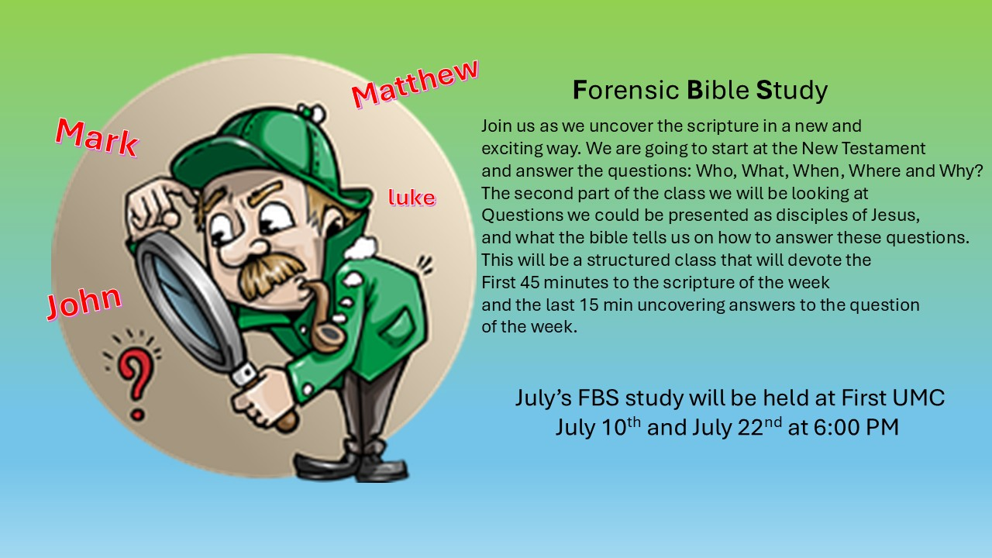
CHURCH KEYS
We are trying to update our Church key list. If you have keys for the Church or buildings, please let Audrey know what you have. Or you can put it down on your connect card. Thank you

JULY MISSION
For July and August Missions, we will be collecting funds for Rise Against Hunger. We will also need some volunteers from the church to work the packing event on September 20th. There will be more information coming on signing up to work. See Emily with any questions

ALTAR FLOWER DATES AVAILABLE IN
JULY 20 AND AUGUST 3, 10, 17, 24, 31
Arrangements are $35.00. See Audrey if interested.

COVENANT CENTER ART SHOW
Attention: Artists and Photographers, the 31st annual show is coming:
July 31-August 4th
Applications are due to Sue by Thursday, July 17, 2025. Questions can be answered at the church office 724-548-4312 or myself at 724-859-2607. Melissa Bureau

HELP NEEDED-PARSONAGE
Today, Sunday July 13 after services we will need assistance loading in the Furniture from the Garage to the Parsonage. Many hands make quick work! The house is clean and we just need to load it in

FRIENDS HELPING FRIENDS
Hello “Friends”! Your friends at Rainbow Road have joined with Boscov’s to bring you, our “friends”, a great savings opportunity. For a donation of $5 we will give you a coupon for 25% off your purchases at the store. The coupon is only good in store on October 22, 2025. Please contact “your friend” Ray Johnson, for your Friends Helping Friends coupon supporting Rainbow Road! Phone 951-965-2121 email: u21sob@gmail.com
HELP NEEDED FOR FOLK FESTIVAL
The successful Lenten Fish Dinners let us give $300 to Grace Presbyterian Food Bank, $300 to the Ford Memorial Food Bank, and $300 to UMCOR domestic disaster from the $6716 proceeds. It is now time to begin preparations for the food booth at the Fort Armstrong Folk Festival. Festival schedule is Thursday July 31, 5:00-10:00PM, Friday, August 1, 12:00-10:00PM, Saturday, August 2, 12:00-10:00PM and Sunday, August 3, 12:00-6:00PM.
Help is needed for the First Church food booth as outlined below. Please help when you can, where you can and as often as possible.
Saturday, July 26 from 9:00-12:00-Help is needed to set up the booth and tent for the festival. This takes many, so all are welcome, no need to sign up.
Booth workers needed: please call Melissa Bureau (724-859-2607) to schedule a time to work in the booth or watch for the schedule at a church service.
Thursday, July 31, 9:00-11:30 AM need help to set up tables and
chairs outside, move refrigerators, freezers and other equipment to booth.
Thursday-Saturday festival evening cleanup- starting about 9:30PM-carry items from booth inside, clean booth and tables, wash all dirty containers and utensils, empty garbage cans…
Sunday Evening Clean up—Many people will be needed to clean up and put away after the festival ends at 6:00 PM on Sunday, August 4th. No need to sign up. Everyone is welcome. Will do some cleanup starting at 5:30 PM.
Please make sure you SIGN IN any time you are working. Thank you. Tim Scaife, Activities Chairman 724-664-5346

RAINBOW ROAD CLASSROOM WISH LIST
Household items:
Paper towels toilet paper tissues hand soap
Band-Aids napkins germ-x
13 gallon kitchen bags Small paper cups
Toys:
10lbs plastic pellets for sensory table $76.59
Viewmaster Science Viewers (set of 3) $49.99
Magnetic wonder tiles $49.99
Rock n gem surprise $24.99
12 pcs color sorting cups $14.99
Spark create imagine 6 pc animal figures $4.97
Arts and crafts:
Bright splash cardstock $5.88 (x4)
Primary pizzaz cardstock $4.97 (x4)
Colorbok snow white cardstock $4.97
Colorbok black cardstock $4.97
Paint dauberes $19.99
Corrugated cardboard paper sheets red $16.99
Corrugated cardboard paper sheets white $19.49

