FIRST CHURCH WEEKLY CALENDAR
SUNDAY, June 29th
10:00 AM Worship
11:00 AM VBS Picnic-CC
Tear Down VBS after Picnic

MONDAY, June 30th

TUESDAY, July 1st
1:00 PM Trustees
7:00 PM New Found Freedom-CC

WEDNESDAY, July 2nd

THURSDAY, July 3rd
Offices Closed for 4th

FRIDAY, July 4th
Happy 4th July

SATURDAY, July 5th
7:00 PM We Surrender- CC

SUNDAY, July 6th
10:00 AM Communion

Like our Facebook page
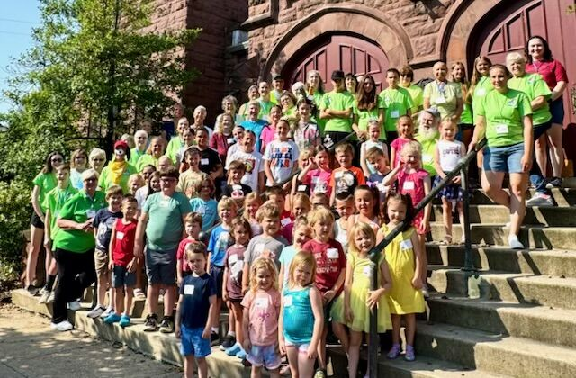

JULY newsletters will be email tomorrow.
If anyone would like a newsletter emailed to them, just put your email on your connect card and I will add you to the list.
June 29, 2025



FIRST UNITED METHODIST CHURCH, 301 N JEFFERSON ST, KITTANNING PA Church Phone: 724-548-4312

E-MAIL: fumchurchkittanning@comcast.net WEBSITE: www.firstchurchkittanning.com

PASTOR: Terri Wells CELL PHONE: 814-952-4695 E-MAIL: terriwells53@aol.com CHURCH OFFICE HOURS: Monday – Thursday 8:00-12:00

PASTOR TERRI OFFICE HOURS: Tuesday & Thursday 10:00 AM-4:00 PM

WELCOME

THEME SONG

PRAYER

PLEDGES

OFFERING/OFFERTORY/*DOXOLOGY/*PRAYER OF DEDICATION
*Praise God, from whom all blessings flow: praise Him all creatures here below; Praise Him above, ye heavenly host; praise Father, Son and Holy Ghost. Amen.

SKIT/VIDEO

PROGRAM-(Each group called up and perform then sit on the floor up front till next ones perform)

Day 1 of Bible School-Grades 3, 4, 5, & 6
Mile Marker-God is with us on the journey
Group Names *Lesson*Scripture*Song

Day 2 of Bible School-Grades 1 & 2
Mile Marker-God is with us when we go off course
Group Names*Lesson*Scripture*Song

Day 3 of Bible School-Kindergarten
Mile Marker-God is with us when we’re joyful
Group Name*Lesson*Scripture*Song

Day 4 of Bible School-Pre-K
Mile Marker-God is with us when we’re lonely
Group Name*Lesson*Scripture*Song

Day 5 of bible School-Pre-School
Mile marker-God is with us near and Far
Group Name*Lesson*Scripture*Song

GROUP SING

CERTIFICATES

TWO CAN TIME

CLOSING PRAYER

THEME SONG

DISMISS TO HOLY HOT DOG TIME

VBS AND JUNE MISSION
Our June mission is Blessings In a Backpack. This group provides weekend food for students in all of our Armstrong School District schools who may have little or no food when at home. For the upcoming school year, they anticipate helping approximately 285 students with the average cost being $105-$125 per student for the year.


COVENANT CENTER ART SHOW
Attention: Artists and Photographers, the 31st annual show is coming:
July 31-August 4th
The committee has met, a judge has been found, and sponsors have been contacted. Applications are on our website. Exciting news this year, we have two new money awards in all categories given by the Armstrong County Arts Council.
Now it is time for you to get started. Artists pick up those brushes and pencils. Photographers keep on snapping those photos. We are anticipating the biggest and best show ever this year and we can’t do it without you. Questions can be answered at the church office 724-548-4312 or myself at 724-859-2607. Melissa Bureau

HELP NEEDED FOR FOLK FESTIVAL
The successful Lenten Fish Dinners let us give $300 to Grace Presbyterian Food Bank, $300 to the Ford Memorial Food Bank, and $300 to UMCOR domestic disaster from the $6716 proceeds. It is now time to begin preparations for the food booth at the Fort Armstrong Folk Festival. Festival schedule is Thursday July 31, 5:00-10:00PM, Friday, August 1, 12:00-10:00PM, Saturday, August 2, 12:00-10:00PM and Sunday, August 3, 12:00-6:00PM.
Help is needed for the First Church food booth as outlined below. Please help when you can, where you can and as often as possible.
Saturday, July 26 from 9:00-12:00-Help is needed to set up the booth and tent for the festival. This takes many, so all are welcome, no need to sign up.
Booth workers needed: please call Melissa Bureau (724-859-2607) to schedule a time to work in the booth or watch for the schedule at a church service.
Thursday, July 31, 9:00-11:30 AM need help to set up tables and
chairs outside, move refrigerators, freezers and other equipment to booth.
Thursday-Saturday festival evening cleanup- starting about 9:30PM-carry items from booth inside, clean booth and tables, wash all dirty containers and utensils, empty garbage cans…
Sunday Evening Clean up—Many people will be needed to clean up and put away after the festival ends at 6:00 PM on Sunday, August 4th. No need to sign up. Everyone is welcome. Will do some cleanup starting at 5:30 PM.
Please make sure you SIGN IN any time you are working. Thank you
Tim Scaife, Activities Chairman 724-664-5346

