FIRST CHURCH WEEKLY CALENDAR
SUNDAY, June 1st
10:00 AM Communion

MONDAY, June 2nd

TUESDAY, June 3rd
1:00 PM Trustees
5:00 PM Rainbow Road Board
7:00 PM New Found Freedom-CC

WEDNESDAY, June 4th

THURSDAY, June 5th

FRIDAY, June 6th

SATURDAY, June 7th
7:00 PM We Surrender- CC

SUNDAY, June 8th
10:00 AM Worship
2:00 PM Camp 43-CC

THE FLOWERS ON THE ALTAR are presented to the Glory of God in honor of Katie’s birthday, given by Ken & Donna Lazan

THANK YOU to the following individuals for assisting with today’s service:
Usher Team: Oxford/Linda VanSicklin Scripture Reader: Carolyn Hancock
Worship Sound System: Tim King
Bell Ringer: Jocelyn King
Welcome Center Greeter: Sarah Heckert
Acolyte: Hallie Hoffman
Live Stream: Sue Hankey

JUNE newsletters are at the doors.
If anyone would like a newsletter emailed to them, just put your email on your connect card and I will add you to the list.
June 1, 2025
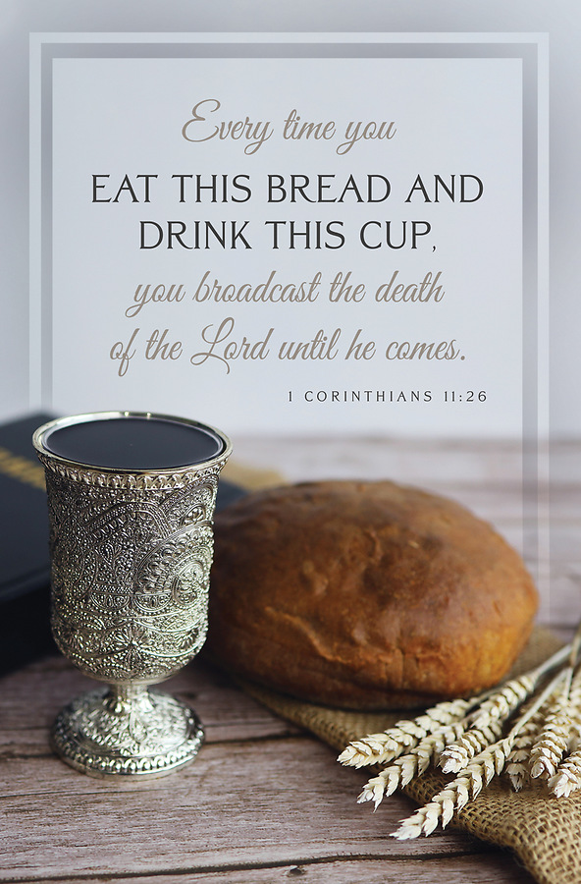

FIRST UNITED METHODIST CHURCH, 301 N JEFFERSON ST, KITTANNING PA Church Phone: 724-548-4312

E-MAIL: fumchurchkittanning@comcast.net WEBSITE: www.firstchurchkittanning.com

PASTOR: Terri Wells CELL PHONE: 814-952-4695 E-MAIL: terriwells53@aol.com CHURCH OFFICE HOURS: Monday – Thursday 8:00-12:00

PASTOR TERRI OFFICE HOURS: Tuesday & Thursday 10:00 AM-4:00 PM

MEDIA SONG “Old Time Religion”-Gospel Music

MUSICAL PRELUDE

ANNOUNCEMENTS

RINGING OF THE WORSHIP BELL

*CALL TO WORSHIP

Leader: Welcome, friends, to this holy day.

People: We come to offer thanks; we come to sing and pray.

Leader: Welcome, friends, to this time set apart,

People: A time to remember those we love, and time to remember the holy promises of God.

Leader: Welcome, friends, to this table of remembrance and joy,

People: The table where we are fed, the feast we share with many.

Leader: Welcome, friends, and let us worship God.

OPENING PRAYER
Almighty and everlasting God, in whom we live and move and have our being, you created us for yourself, so that our hearts are restless until they find rest in you. Grant to us such piety of heart and strength of purpose that no selfish passion may hinder us from knowing your will, and no weakness from doing it. In your light may we see life clearly and in your service find perfect freedom; through Jesus Christ our Lord. Amen.
(THE BOOK OF WORSHIP 1965, ALT.)

HYMN “Holy, Holy, Holy! Lord God Almighty” No. 64

JOYS AND CONCERNS/PASTORAL PRAYER/LORD’S PRAYER

SPECIAL MUSIC

SCRIPTURE John 17:20-26 NKJ Version N.T. p. 111
Leader: this is the Word of God, for the people of God,
People: Thanks be to God.

SERMON “The Care of Christ”

COMMUNION (A Service of Word and Table 1-Page6 in the UMH) Communion will be done by groups coming to the altar. I will serve the bread first, then give the direction to eat as one body at the railing. Then I will serve the cups, give direction to take and drink as one body. I will offer send forth the first group and call the next group. This will continue until all have been served. I will then take to any individuals that cannot physically come forward to receive.

CHILDREN’S SERMON

OFFERING/OFFERTORY/*DOXOLOGY/*PRAYER OF DEDICATION
*Praise God, from whom all blessings flow: praise Him all creatures here below; Praise Him above, ye heavenly host; praise Father, Son and Holy Ghost. Amen.

OFFERING PRAYER
O Lord our God, you are always more ready to bestow your good gifts on us than we are to seek them, and are willing to give more than we desire or deserve. Help us soto seek that we may truly find, so to ask that we may joyfully receive, so to knock that the door of your mercy may be opened to us; through Jesus Christ our Savior. Amen. (THE BOOK OF COMMON PRAYER OF THE CHURCH OF ENGLAND, 20TH CENTL, ALT.)
*HYMN “Near to the Heart of God” No. 472

*BENEDICTION
The Lord bless thee, and keep thee: The Lord make his face shine upon thee, and be gracious unto thee: The Lord lift up his countenance upon thee, and give thee peace. KJV “Numbers 6:24-26”

*Please stand in spirit or in body.
Ask an usher for a large print hymnal or bible or personal hearing device.

VBS
(June 23-27) 9:00-noon
VBS REGISTRATION FORMS ARE AT EACH DOOR.

JUNE MISSION
Our June mission is Blessings In a Backpack. This group provides weekend food for students in all of our Armstrong School District schools who may have little or no food when at home. For the upcoming school year, they anticipate helping approximately 285 students with the average cost being $105-$125 per student for the year.

COVENANT CENTER ART SHOW
Attention: Artists and Photographers, the 31st annual show is coming:
July 31-August 4th
The committee has met, a judge has been found, and sponsors have been contacted. Applications will be out on May 1st and the website has been updated. Exciting news this year, we have two new money awards in all categories given by the Armstrong County Arts Council.
Now it is time for you to get started. Artists pick up those brushes and pencils. Photographers keep on snapping those photos. We are anticipating the biggest and best show ever this year and we can’t do it without you. Questions can be answered at the church office 724-548-4312 or myself at 724-859-2607. Melissa Bureau
YOU ARE INVITED
You are invited to celebrate June Pollard’s 100th birthday! Join us for an open house on Wednesday, June 18, 2025 from 1:00-4:00 PM at 187 Indian Hills Road, Kittanning. Your friendship is the greatest gift, we need nothing more. Cards are also welcomed.

UPDATED PARSONAGE LIST
Dear FUMC Family Members,
The Trustees are presently preparing the parsonage as a rental property for traveling medical professionals and other business professionals. To provide a comfortable and welcoming environment, we are asking for donations of gently used furniture or soft goods. Or if you prefer to give cash donations for the purchase of items, all would be greatly appreciated. Our objective is to offer a tastefully furnished residence for individuals who are temporarily relocating for job-related purposes. We have identified the following items as essential for furnishing the residence. If you are willing to donate any of these items from your attics, basements, or garages, please contact Kimberley Johnosn to coordinate the details. Kim can be contacted at Kimmerk0926@gmail.com or 661-494-2047.

KITCHEN ITEMS:
Pots & Pans for cooking/baking
Utensils & Silverware (ladles, pancake/cookie turners)
Coffeemaker
Small appliances (toaster, air fryer, blender, microwave, etc.)
Starter supplies (paper towels, hand towels, trash bags, dish soap, scrub brushes, etc.)

LIVING ROOM
2 chairs Coffee Table Smart TV
High-speed WIFI Rug Pillows/décor
Throw blankets

4 BEDROOMS
Bed Frames headboard (ideally full/queen if possible)
8 Full/Queen sets of sheets (preferably white)
3 Nightstands 4 Lamps 3 Dressers 4-24/32 Smart TV
8 Bed Pillows Rugs Full Length Mirror
Hangers Trash Cans Pillow/Mattress covers
2 BATHROOMS
Trash Can Bath Towels (including an extra set) prefer white
Bathmat/rugs Toilet plunger and brush Hair Dryer

LAUNDRY AREA
Appliances (iron, steamer, ironing board) Drying Rack
Laundry detergent Dryer Sheets

CLEANING SUPPLIES (3-4 DAYS WORTH)
Dish Soap Hand Soap Sponges Dishwasher Detergent All-Purpose Cleaner Paper Towels
Dish Towels Trash Bags Vacuum Mop/Swiffer Broom/Dustpan

WHAT WE DON’T NEED
Live plants Speakers Board Games Excessive décor
Candles

