FIRST CHURCH WEEKLY CALENDAR
SUNDAY, May 4th
8:30 AM Youth Sunday School
9:00 AM Children’s Sunday School
10:00 AM Worship

MONDAY, May 5th

TUESDAY, May 6th
6:30 PM Charge SPRC-First
7:00 PM New Found Freedom-CC

WEDNESDAY, May 7th

THURSDAY, May 8th

FRIDAY, May 9th

SATURDAY, May 10th
7:00 PM We Surrender- CC

SUNDAY, May 11th
8:30 AM Youth Sunday School
9:00 AM Children’s Sunday School
10:00 AM Worship

THE FLOWERS ON THE ALTAR are presented to the Glory of God
In loving memory of Jim & Eileen Hodgson, given by the family

THANK YOU to the following individuals for assisting with today’s service:
Usher Team: Asbury/Donna Lazan
Scripture Reader:
Worship Sound System: Tim King
Bell Ringer: Jocelyn King
Welcome Center Greeter: Sarah Heckert
Acolyte: Caden King
Live Stream: Sue Hankey

MAY newsletters are at the doors.
If anyone would like a newsletter emailed to them, just put your email on your connect card and I will add you to the list.

May 4, 2025
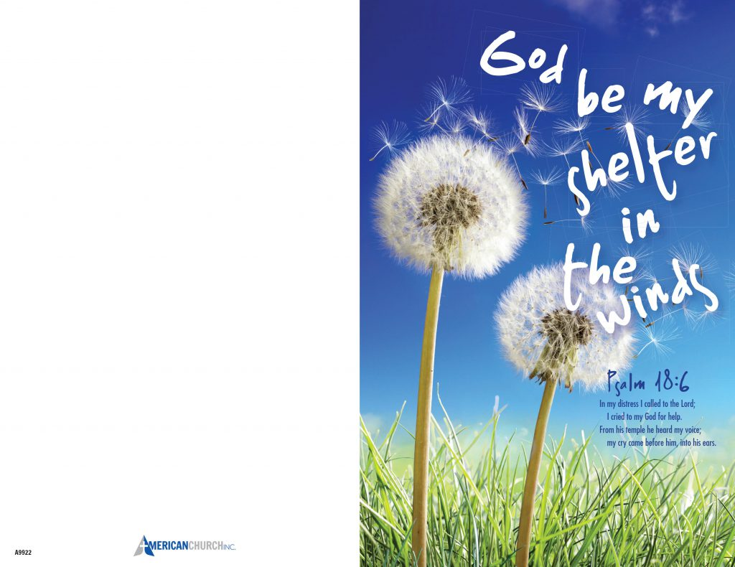

FIRST UNITED METHODIST CHURCH, 301 N JEFFERSON ST, KITTANNING PA Church Phone: 724-548-4312

E-MAIL: fumchurchkittanning@comcast.net WEBSITE: www.firstchurchkittanning.com

PASTOR: Terri Wells CELL PHONE: 814-952-4695 E-MAIL: terriwells53@aol.com CHURCH OFFICE HOURS: Monday – Thursday 8:00-12:00

PASTOR TERRI OFFICE HOURS: Tuesday & Thursday 10:00 AM-4:00 PM

MEDIA SONG “Heart of God” by Zach Williams

MUSICAL PRELUDE

ANNOUNCEMENTS

RINGING OF THE WORSHIP BELL

*CALL TO WORSHIP

Leader: God, you call us from the corners of the Earth.

People: From the cities and the prairies, from the ghettos and the tables of the wealthy.

Leader: God, you sing to us from the corners of the universe.

People: In the gentle ocean breeze, in the colors that burst forth from our landscapes, in the faces of children ravaged by war.

Leader: God, you speak to us from the corners of the Earth.

People: to the east, to the west, to the north, and to the south, above us, below us, and within us, your voice rings clear. Send your voice to sing in us, we pray, as we worship this day.

OPENING PRAYER
God of love, we bring our very selves to worship. Our triumphs. Our failures. Our vulnerabilities. Our greatest joys and our deepest sorrows. In this time set apart, may we hear the voice of Jesus urging us to feed and be fed, to love and be loved. Amen.

OPENING HYMN “Sweet Hour of Prayer” No. 496

JOYS AND CONCERNS/PASTORAL PRAYER/LORD’S PRAYER

OFFERING/OFFERTORY/*DOXOLOGY/*PRAYER OF DEDICATION
*Praise God, from whom all blessings flow: praise Him all creatures here below; Praise Him above, ye heavenly host; praise Father, Son and Holy Ghost. Amen.

*HYMN OF PREPARATION “O How I Love Jesus” No. 170

CHILDREN’S SERMON

SCRIPTURE Acts 9:1-20 N.T. p. 127
Leader: this is the Word of God, for the people of God,
People: Thanks be to God.

SERMON “Attention Grabbers”

*CLOSING HYMN “It is Well With My Soul” No. 377

*BENEDICTION

*Please stand in spirit or in body.
Ask an usher for a large print hymnal or bible or personal hearing device.

We thank Vicki Shaeffer for filling in for Pastor Terri today.

ANNUAL SPRING CLEAN UP
VOLUNTEERS NEEDED
Let’s spruce up our church for the season. Weed, leaves, litter, and clippings all need removed. Saturday, May 3 @ 10:00 AM. (Rain date, Saturday, May 10th @ 10:00 AM) Rubbish bags will be supplied. Please bring your garden gloves and/or preferred garden tools if you like. Contact Ken Lazan @ 724-664-4037 to confirm.

JUNE NEWSLETTER DEADLINE, SUNDAY, MAY 25TH
I WILL DO JULY SEPARATE THIS YEAR.

MARK YOUR CALENDARS
VBS WORKDAY
We will be having our annual VBS workday on Saturday, May 17th beginning at 9:00 AM. This will be held at Audrey Green’s house. 140 Upper Hayes Run Road, Kittanning. (Take 66/28 towards New Bethlehem. Take Anderson Creek Road at the top of hill on right. Go 1 ½ miles, turn left onto Upper Hayes Run Road, first left on that road. 2nd house, blue truck mailbox at end of driveway.) There will be something for everyone. Painting, cutting, glueing, etc… (nothing too hard) Please let Audrey or Sue know if you will be coming. Thank you, see you there.

VBS 2025
VBS will be held the week of June 23-27 from 9 to noon. We have selected Cokesbury's VBS "Road Trip-On the Go with God". Let Sue Hankey or the office know if you are interested in helping this year. We still need crew leaders.

MAY MISSION
We are going to collect donations for the Hope Center Ministries. Hope Center Ministries is a nonprofit organization that operates a Christ-centered recovery program for alcoholics and addicts. They were founded in 2007 with the intention of providing a practical and effective solution to the epidemic of addiction in our society. THE PURPOSE of Hope Ministries is to provide men and women with the opportunity to overcome their drug and alcohol addiction through their faith. THE PROGAM is designed to show these individuals how to find peace and lasting freedom from their addictions through a personal relationship with Jesus Christ. THEY OFFER a 12-month program for those struggling with drug and alcohol addiction.

MAY SIFT LUNCHEON
The May SIFT Luncheon will be held on Thursday, May 15, 2025, at noon in the Covenant Center. The menu will be the annual end-of-the-year picnic. Hot Dogs, buns, sauerkraut and baked beans will be provided. Attendees are asked to bring a side dish or dessert to share. Those attending will learn about the monarch butterfly and will be entertained by the children of Rainbow Road Preschool. Reservations can be made from Monday, April 28 through noon on Monday, May 12. Please call 724 548-4312. Phone reservations only will be accepted and will be limited to 75. You will need to give a name for each reservation made along with a contact phone number. Please call to cancel as there may be a waiting list. Doors will open at 11:30 AM. Please use the parking lot door.
See YOU there!

COVENANT CENTER ART SHOW
Attention: Artists and Photographers, the 31st annual show is coming:
July 31-August 4th
The committee has met, a judge has been found, and sponsors have been contacted. Applications will be out on May 1st and the website has been updated. Exciting news this year, we have two new money awards in all categories given by the Armstrong County Arts Council.
Now it is time for you to get started. Artists pick up those brushes and pencils. Photographers keep on snapping those photos. We are anticipating the biggest and best show ever this year and we can’t do it without you. Questions can be answered at the church office 724-548-4312 or myself at 724-859-2607. Melissa Bureau

