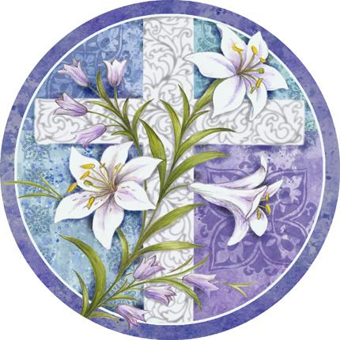

2025 Easter Flowers
The flowers in our sanctuary speak of new life. They remind us so beautifully of Christ's resurrection and are presented to the Glory of God by the following.

IN MEMORY OF:
Husband, Fred (1 Hyacinth)
Son, Guy (1 Hyacinth) Given by Gail Blaney

Husband, Lowell Dean (1 Hyacinth)
Parents, Walter & Beth Buhite (1 Mini Daffodil)
Given by Marybeth Dean

Husband, Bernie Green
Parents, Bob & Jean Schaeffer (1 Tulip)
Given by Audrey Green
IN MEMORY OF:
Violet, Leonard & Kenny Pierson & Elaine Leas (1 Tulip)
Elmer, Rosalie & Jay Heckert (1 Tulip)
Given by Joe & Sarah Heckert

La Covda & Kenny Bach (2 Tulips)
John & Virginia Johnson (2 Tulips)
Tommy Lane (1 Tulip)
In remembrance of their gentle spirits
Given by Ray & Kim Johnson

Our Grandparents (1 Tulip)
Given by Tim & Emily King

Loved Ones (2 Hyacinths)
Given by Ken & Donna Lazan

Olive King (1 Hyacinth)
Given by Niece, Nelda Martin
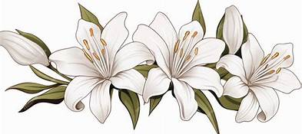

IN HONOR OF:
My Children, and Grandchildren (1 Tulip)
Given by Audrey Green

Children, Grandchildren & Great Grandson (1 Mini Daffodil)
Given by Joe & Sarah Heckert

Our Parents & Children (1 Tulip)
Given by Tim & Emily King

