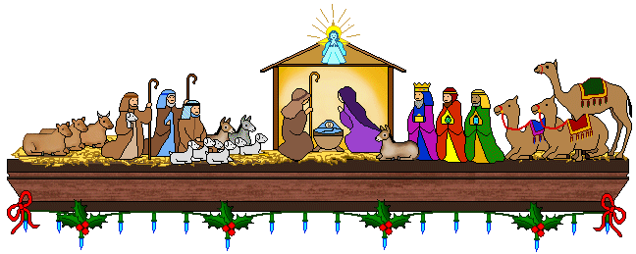

CHRISTMAS POTLUCK
Sunday, December 22, 2024
Covenant Center
12:00 PM

Ham and Beverage will be provided.
Anyone attending is asked to bring
Side dish or Dessert to share.

Deadline: Sunday, December 15, 2024
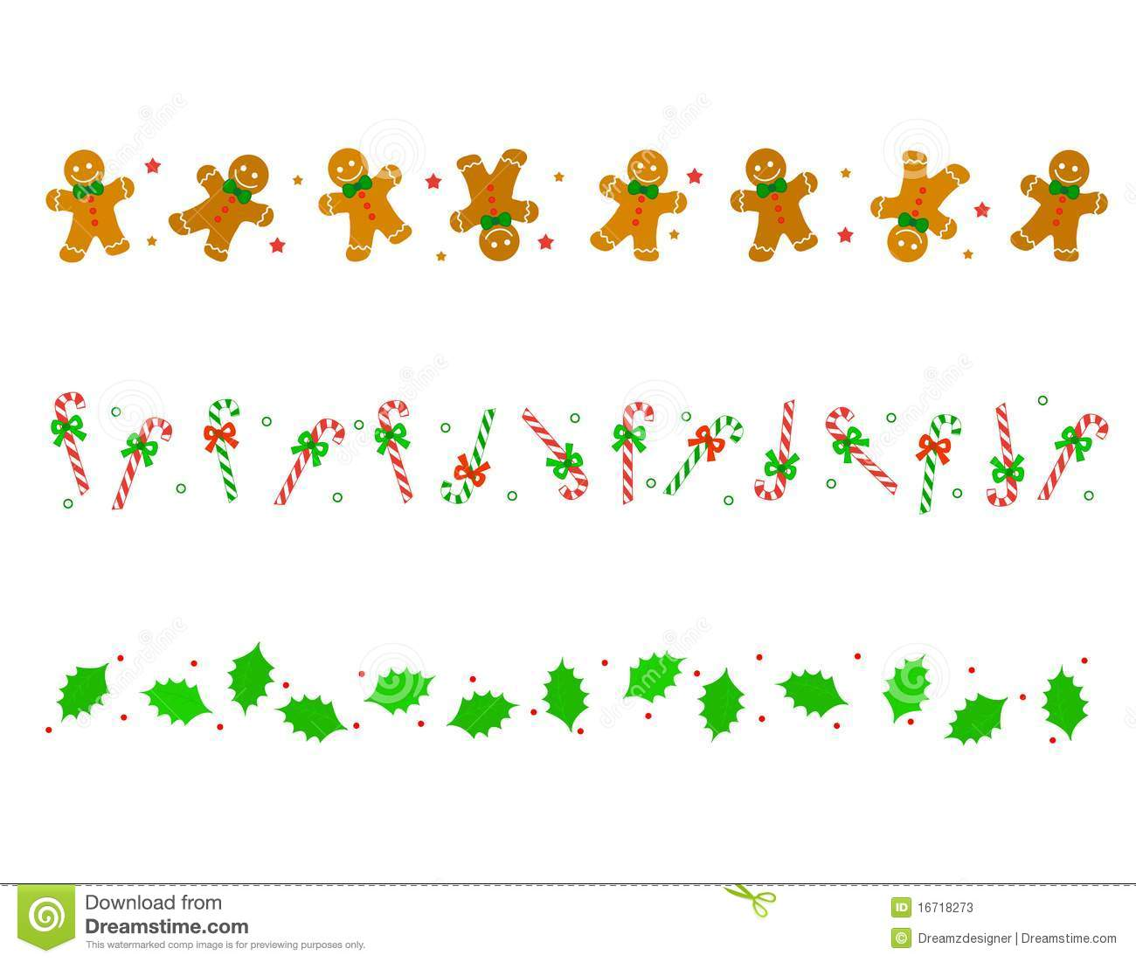

Please return reservations in the offering plate or church office. Thank you!

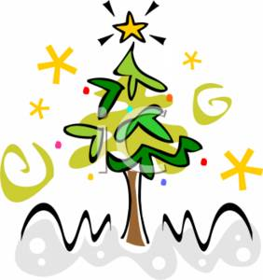
NAME :_________________________________

NUMBER ATTENDING: ________________

PHONE:____________________________________

CHRISTMAS POTLUCK
Sunday, December 22, 2024
Covenant Center
12:00 PM

Ham and Beverage will be provided.
Anyone attending is asked to bring
Side dish or Dessert to share.

Deadline: Sunday, December 15, 2024

Please return reservations in the offering plate or church office. Thank you!
NAME :_________________________________

NUMBER ATTENDING: ________________

PHONE:______________________________

