POSTLUDE

*Please stand in spirit or in body.
Ask an usher for a large print hymnal or bible or personal hearing device.

The First United Methodist Church offices will be closed between Christmas Eve and New Year’s Day. It will reopen on Thursday, January 2, 2025.

For pastoral emergencies, feel free to contact Pastor Dayton Mix at 724-718-2997 until December 31, 2024 and Pastor Terri Wells at 814-952-4695 beginning January 1, 2025.

FIRST UNITED METHODIST CHURCH, 301 N JEFFERSON ST, KITTANNING PA 16201

724-548-4312

E-MAIL: fumchurchkittanning@comcast.net WEBSITE: www.firstchurchkittanning.com

SENIOR PASTOR: Dayton D. Mix PASTOR: Terri Wells CHURCH OFFICE HOURS

CELL PHONE: 724-718-2997 CELL PHONE: 814-952-4695 Monday-Thursday 8:00-12:00

E-MAIL: pastordayton@gmail.com E-MAIL: terriwells53@aol.com

KNOW JESUS, REFLECT JESUS, LEAD OTHERS TO JESUS

Remember to pick up your poinsettias after worship tonight.



December 24, 2024

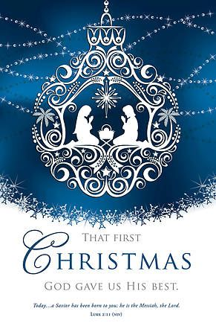

PRELUDE

*CALL TO WORSHIP

Leader: To us a child is born.

People: To us a Son is given.

Leader: Great is the Lord, and greatly to be praised,

People: For we have known Emmanuel, God-with-us!
–adapted from Isaiah 9 & Psalm 96 in And Also With You (year C), p.12

OPENING PRAYER

* HYMN “O Come All Ye Faithful” No. 234

ADVENT WREATH LIGHTING

*HYMN “What Child Is This?” No. 219

SCRIPTURE Matthew 1:18-25

SPECIAL MUSIC “Mary Did You Know?”

SCRIPTURE Luke 2:1-7

ANTHEM “Were You there On that Christmas Night?”

CHILDREN’S TIME

*HYMN “Away In A Manger” No. 217

OFFERING/OFFERTORY/DOXOLOGY/PRAYER OF DEDICATION
*Praise God, from whom all blessings flow: praise Him all creatures here below; Praise Him above, ye heavenly host; praise Father, Son and Holy Ghost. Amen.

………WITNESSES TO CHRISTMAS:ANGELS & SHEPHERDS……….

*HYMN “Angels We have Heard on High” No. 238

SCRIPTURE Luke 2:8-20

ANTHEM “When Love Came Down”

……………..WITNESSES TO CHRISTMAS:ALL CHRISTIANS…………..

SCRIPTURE Acts 1:6-8

SCRIPTURE John 13:34-35

HOMILY “Keep Christ in Christmas”

ANTHEM/HYMN/SPECIAL MUSIC “O Holy Night”-Ray Johnson

*CANDLE LIGHTING & HYMN “Silent Night” On Screen
As the acolytes pass the light to members of the congregation, pass it to the person next to you. Please, DO NOT TIP a lighted candle.

(With the start of verse 4, we raise our candles to honor the Christ, the Savior and giver of our peace.)

PRAYER

*HYMN “Joy To The World” No. 246

BENEDICTION

