FIRST CHURCH WEEKLY CALENDAR
SUNDAY, December 22nd
Fourth Sunday of Advent
9:30 AM Sunday School
11:00 AM Worship-Children’s Christmas Play
12:00 PM Christmas Pot-luck-CC

MONDAY, December 23rd

TUESDAY, December 24th
7:00 PM Christmas Eve Service
7:00 PM New Found Freedom-CC

WEDNESDAY, December 25th
Merry Christmas

THURSDAY, December 26th

FRIDAY, December 27th

SATURDAY, December 28th
7:00 PM We Surrender- CC

SUNDAY, December 29th
11:00 AM Worship

FIRST UNITED METHODIST CHURCH, 301 N JEFFERSON ST, KITTANNING PA 16201

724-548-4312

E-MAIL: fumchurchkittanning@comcast.net WEBSITE: www.firstchurchkittanning.com

SENIOR PASTOR: Dayton D. Mix PASTOR: Terri Wells CHURCH OFFICE HOURS

CELL PHONE: 724-718-2997 CELL PHONE: 814-952-4695 Monday-Thursday 8:00-12:00

E-MAIL: pastordayton@gmail.com E-MAIL: terriwells53@aol.com

KNOW JESUS, REFLECT JESUS, LEAD OTHERS TO JESUS

NO SUNDAY SCHOOL ON SUNDAY, DECEMBER 29, 2024

THANK YOU to the following individuals for assisting with today’s service:
Usher Team: Asbury/Donna Lazan
Scripture Reader: Sue Hankey
Worship Sound System: Carlee Beers
Bell Ringer: Eliana McGregor
Welcome Center Greeter:
Acolyte: Elizabeth Mix
Live Stream: Steph Hankey

December 22, 2024
Fourth Sunday of Advent

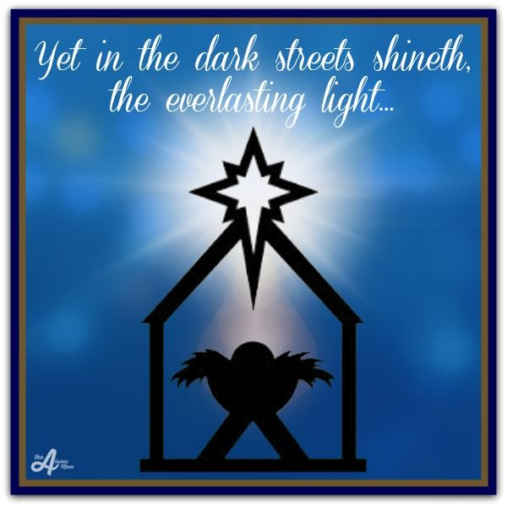

PRELUDE

RINGING OF THE WORSHIP BELL

*CALL TO WORSHIP

Leader: Let us magnify the Lord.

People: Let us rejoice in God our Savior.

Leader: The Mighty One has done great things for us;

People: Holy is God’s Name!
–adapted from Luke 1 in And Also With You (year C), p.10

OPENING PRAYER

* HYMN “Away In A Manger” No. 217

CHILDREN’S TIME “The Birth of Jesus” - Children’s Christmas Play

MINISTRY MOMENT

MORNING ANTHEM “Born To Set Us Free”

OFFERING/OFFERTORY/*DOXOLOGY/*PRAYER OF DEDICATION
*Praise God, from whom all blessings flow: praise Him all creatures here below; Praise Him above, ye heavenly host; praise Father, Son and Holy Ghost. Amen.

LIGHTING OF THE ADVENT WREATH

JOYS AND CONCERNS/PASTORAL PRAYER/LORD’S PRAYER

SCRIPTURE READING Luke 4:14-30 N.T. p. 61
Leader: This is the Word of God, for the people of God,
People: Thanks be to God

SERMON “All Earth Is Waiting” Hymn 210 “All Earth Is Waiting”

*HYMN “O Come, All Ye Faithful” (verses 1-4) No. 234

*Altar rail is open for prayer during the closing hymn.

*BENEDICTION
*Please stand in spirit or in body.
Ask an usher for a large print hymnal or bible or personal hearing device.

CHRISTMAS EVE SERVICES FOR FIRST CHURCH AND
FORD MEMORIAL AT 7:00 PM

2025 NEWSLETTERS
Our newsletters are going digital beginning with our January 2025 newsletter. We will no longer be mailing out our newsletters. You can go to the website www.firstchurchkittanning.com/about and download a copy. We can email it to you, just email us your email address at fumchurchkittanning@comcast.net. Or you can pick up a paper copy at one of the doors.

WINTER IS COMING!
The Trustees have arranged for snow plowing for the coming season, but we are in need of someone to clear the walks around the church and Covenant Center. If you know someone available for this task, please let us know as soon as possible. Call Ken Lazan at 724-664-4037 or contact the church office.

DECEMBER MISSION
Our missions for December will be donations to the food bank at Grace Presbyterian Church. Please consider making a donation for our community members who may struggle for a quality meal, especially around the holidays. Donations can be left on the alter railing.

DART BALL
We will have a Dart Ball Open House on Monday, January 13, 2025 at 7:00 PM in the Church Basement. Any questions please call Scott Jamison at 724-525-5371.

PEOPLE UNABLE TO BE HERE
While preparing for the holidays, please consider corresponding with those that are unable to be here. Here are a few along with perhaps unknown addresses. Please make (the church 724-548-4312, Kathy Riffer 724-545-1619 and Kim Johnson 661-494-2047) aware of any that need to be included as we want to be in contact with everyone.
- Harry & Michelle Waldenville, apt 3D, 280 S McKean St,
Kittanning PA 16201
- Donna King, Rivercliff Terrace, 120 Allegheny Ave, Kittanning PA 16201
- June Pollard, 187 Indian Hills, Kittanning PA 16201
- Sally Felton, Apt 2, 500 N Grant Ave, Kittanning PA 16201
- Edna Heighley, 11386 State Route 85, Kittanning PA 16201
- Roy Williamson, Concordia At Cabot, 134 Marwood Rd, Lund Building, Room 2020, Cabot PA 16023
- Marlene Colville, Rivercliff Terrace, 120 Allegheny Ave, Kittanning PA 16201
- William Waters, 727 Mani St, Ford City, PA 16226
- Esther & Frank Kiss, 153 State Route 1035, Kittanning PA 16201
- Ada Bowser, 244 Ridge Ave, Apt 4, Kittanning PA 16201
- Linda Scaife, The Gardens at Indiana, Room 210, 2720 W Pike Rd, Indiana PA 15701

