Happy Holidays from your Youth
Let us Help you reduce your stress with the Christmas Holiday
Mark the number of cookie by the type of cookie. All cookies are sold by the dozen.

And check cookie baking off your list.
______Chocolate Chip

______Sugar-assortment w/wo sprinkles ______Raisin Filled
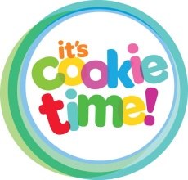
______Orange ______Total Dozen @ $10.00

______Kiss

______Snickerdoodles Payment Amount $_______________

______ Total dozen @ $9.00 Payment Method __________________

Name_______________________________________________________________________

I would like to donate money/supplies:_____________________________________________
Any questions or to place an order: call Melissa 724-859-2607

*Deadline to order-December 8th *Pick up date-December 22@Covenant Center 12:00
Happy Holidays from your Youth
Let us Help you reduce your stress with the Christmas Holiday
Mark the number of cookie by the type of cookie. All cookies are sold by the dozen.
And check cookie baking off your list.
______Chocolate Chip

______Sugar-assortment w/wo sprinkles ______Raisin Filled
______Orange ______Total Dozen @ $10.00

______Kiss

______Snickerdoodles Payment Amount $_______________

______ Total dozen @ $9.00 Payment Method __________________

Name_______________________________________________________________________

I would like to donate money/supplies:_____________________________________________
Any questions or to place an order: call Melissa 724-859-2607

*Deadline to order-December 8th *Pick up date-December 22@Covenant Center 12:00

