
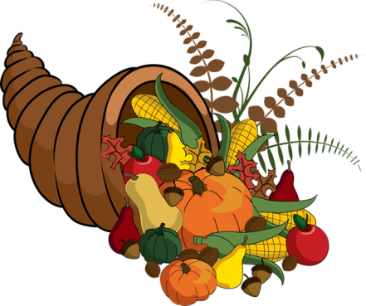
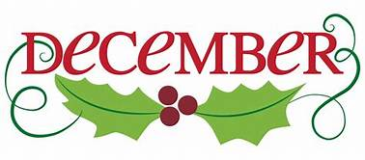
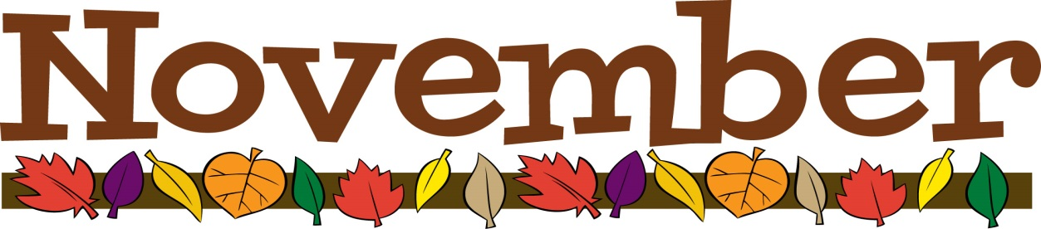
SUNDAY | MONDAY | TUESDAY | WEDNESDAY | THURSDAY | FRIDAY | SATURDAY
 |  |  |  |  |   1 | 2  7:00 PM We Surrender-CC
3 (W)  All Saints Sunday  9:00 AM Communion (Union)  9:30 AM Sunday School (First)  11:00 AM Communion (First) (Ford)  2:00 PM Camp 43-CC | 4  6:30 PM Trustees (First) |   5  7:00 PM New Found Freedom-CC | 6  6:30 PM Choir (First) | 7  6:30 PM Safety Team (First) | 8 | 9  7:00 PM We Surrender-CC
10 (G)  9:00 AM Worship (Union)  9:30 AM Sunday School (First)  11:00 AM Worship (First) (Ford) |   11  7:00 PM Nurture, Outreach & Witness  (First) | 12  7:00 PM New Found Freedom-CC | 13  9:00 AM Glenna Cook-CC  6:30 PM Choir (First) | 14  9:00-3:00 PM Rainbow Road-CC | 15  9:00-3:00 PM Rainbow Road-CC | 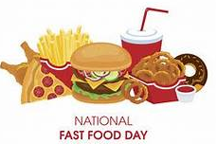  16  7:00 PM We Surrender-CC
17 (G)  9:00 AM Worship (Union)  9:30 AM Sunday School (First)  11:00 AM Worship (First) (Ford)  12:00 PM Choir (First)  DECEMBER CHARGE NEWSLETTER DEADLINE | 18  6:30 PM Finance (First)  7:00 PM Church Council (First) | 19  Holiday Pie orders due  7:00 PM New Found Freedom-CC | 20   | 21  12:00 PM SIFT Luncheon-CC | 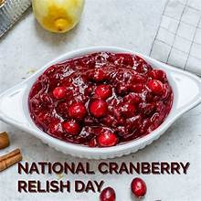  22 | 23  7:00 PM We Surrender-CC
24 (W)  CHRIST THE KING SUNDAY  United Methodist Students Day  9:00 AM Worship (Union)  9:30 AM Sunday School (First)  11:00 AM Worship (First) (Ford) | 25 | 26  9:00 AM Decorate Church for Christmas (First)  7:00 PM New Found Freedom-CC | 27  6:30 PM Pick up Holiday Pies-CC | 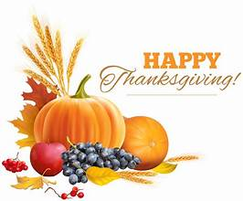  28 | 29 | 30  4:00-7:00 PM A Journey to the Stable (Ford)  7:00 PM We Surrender-CC

