FIRST CHURCH WEEKLY CALENDAR
SUNDAY, November 10th
9:30 AM Sunday School
11:00 AM Worship

MONDAY, November 11th
7:00 PM Nurture, Outreach, Witness

TUESDAY, November 12th
7:00 PM New Found Freedom-CC

WEDNESDAY, November 13th
8:00 AM ? Glenna Cook-CC
6:30 PM Choir

THURSDAY, November 14th
9:00 -3:00 PM Rainbow Road-CC

FRIDAY, November 15th
9:00-3:00 PM Rainbow Road-CC

SATURDAY, November 16th
7:00 PM We Surrender- CC

SUNDAY, November 17th
9:30 AM Sunday School
11:00 AM Worship
December Newsletter Deadline

FIRST UNITED METHODIST CHURCH, 301 N JEFFERSON ST, KITTANNING PA 16201

724-548-4312

E-MAIL: fumchurchkittanning@comcast.net WEBSITE: www.firstchurchkittanning.com

SENIOR PASTOR: Dayton D. Mix PASTOR: Terri Wells CHURCH OFFICE HOURS

CELL PHONE: 724-718-2997 CELL PHONE: 814-952-4695 Monday-Thursday 8:00-12:00

E-MAIL: pastordayton@gmail.com E-MAIL: terriwells53@aol.com

KNOW JESUS, REFLECT JESUS, LEAD OTHERS TO JESUS

CONGRATULATIONS TO Robyn and Tony Green on the birth of their daughter, Violet Mae Green. Violet was born on Thursday, October 31, 2024. She was 7lbs 1oz and 19 inches long. She is the sister to Logan, Wyatt and Olivia Green and the granddaughter of Audrey and Bernie Green.

THE FLOWERS on the altar are presented to the Glory of God in memory of Libby & Edna Stennett, given by Sally & Tony Krozely

THANK YOU to the following individuals for assisting with today’s service:
Usher Team: Epworth/Melissa Bureau
Scripture Reader: Carolyn Hancock
Worship Sound System: Tim King
Bell Ringer: Olivia Green
Welcome Center Greeter: Melissa Bureau
Acolyte: Jocelyn King
Live Stream: Sue Hankey

November 10, 2024

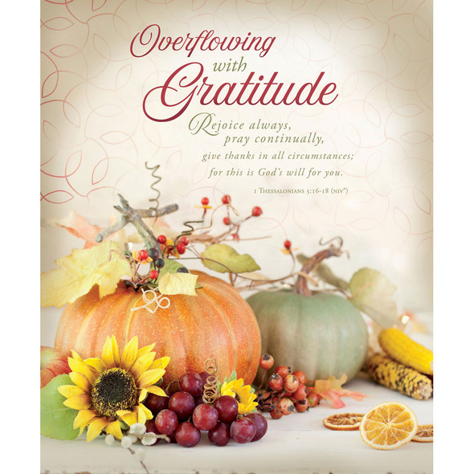

PRELUDE

RINGING OF THE WORSHIP BELL

*CALL TO WORSHIP Psalms 42 & 127

Leader: Unless the Lord builds the house,

People: Those who build it labor in vain.

Leader: Hope in God and praise the Lord.

People: The Lord is our help and our God.

OPENING PRAYER

* HYMN “Heralds of Christ” No. 567

MINISTRY MOMENT

CHILDREN’S TIME

MORNING ANTHEM “Spirit Song”

OFFERING/OFFERTORY/*DOXOLOGY/*PRAYER OF DEDICATION
*Praise God, from whom all blessings flow: praise Him all creatures here below; Praise Him above, ye heavenly host; praise Father, Son and Holy Ghost. Amen.

JOYS AND CONCERNS/PASTORAL PRAYER/LORD’S PRAYER

*HYMN “Help Us Accept Each Other” No. 560

SCRIPTURE READING N.T. p.
Leader: This is the Word of God, for the people of God,
People: Thanks be to God.

SERMON “Being a Christian When Your Candidate Loses (or Wins)
Romans 13:1-7, 1 Timothy 2:1-2, 1 Peter 2:13-17

*HYMN “Rejoice The Lord is King” No. 715

*Altar rail is open for prayer during the closing hymn.

*BENEDICTION
*Please stand in spirit or in body.
Ask an usher for a large print hymnal or bible or personal hearing device.

REMEMBER TO ORDER YOUR POINSETTIAS BY NOVEMBER 17TH

NOVEMBER MISSION
Our missions for November and December will be donations to the food bank at Grace Presbyterian Church. Please consider making a donation for our community members who may struggle for a quality meal, especially around the holidays. Donations can be left on the alter railing.

DECORATE THE CHURCH FOR CHRISTMAS
Everyone is invited to join us in decorating our church for Christmas Tuesday, November 26, 2024. We begin at 8:30 AM and are usually finished by noon. Come enjoy the fellowship and get in the Christmas spirit.

ADVENT
Advent is coming. The Christian Education team is planning to have an adult Sunday School class (9:30-10:30 AM) during the Advent season. Watch for more details in future bulletins.

CHRISTMAS PRELUDE MUSIC
We are looking for anyone who would like to help provide prelude music prior to our Christmas Eve Candlelight service. Preludes start 30 minutes before the service. Please contact Emily King if you would be willing to share your gift with the congregation at 724-664-0098.

VBS FOR 2025
VBS is scheduled for the week of June 23-27, 2025. Please prayerfully consider where you can fit into this outreach program (teachers, games leader, snacks, monetary, crew leaders, decorations….) watch future newsletters/bulletins for more information.

NOVEMBER SIFT LUNCHEON
The November SIFT Luncheon will be held on Thursday, November 21, 2024, at noon in the Covenant Center. The menu will be Thanksgiving Dinner, turkey, stuffing, mashed potatoes, corn, green beans, cranberries, rolls and butter, pie. The program, Creative Seed Sacks-Louise Baker. Reservations can be made from Monday, November 4th through noon on Monday, November 18th. Please call 724-548-4312. Phone reservations only will be accepted and will be limited to 75. You will need to give a name for each reservation made along with a contact phone number. Please call to cancel as there may be a waiting list. Doors will open at 11:30 AM. Please use the parking lot door. See YOU there!

A JOURNEY TO THE STABLE
“Go back in time to a Biblical Marketplace filled with surprises!”
At Ford Memorial UM Church, Ford City
Saturday, November 30 and Sunday, December 1st
4:00-7:00 PM nightly
Open to the public. Free admission.

