FIRST CHURCH WEEKLY CALENDAR
SUNDAY, November 3
All Saints Sunday
9:30 AM Sunday School
11:00 AM Communion
2:00 PM Camp 43-CC

MONDAY, November 4th
6:30 PM Trustees

TUESDAY, November 5th
7:00 PM New Found Freedom-CC

WEDNESDAY, November 6th
6:30 PM Choir

THURSDAY, November 7th

FRIDAY, November 8th

SATURDAY, November 9th
7:00 PM We Surrender- CC

SUNDAY, November 10th
9:30 AM Sunday School
11:00 AM Worship

FIRST UNITED METHODIST CHURCH, 301 N JEFFERSON ST, KITTANNING PA 16201

724-548-4312

E-MAIL: fumchurchkittanning@comcast.net WEBSITE: www.firstchurchkittanning.com

SENIOR PASTOR: Dayton D. Mix PASTOR: Terri Wells CHURCH OFFICE HOURS

CELL PHONE: 724-718-2997 CELL PHONE: 814-952-4695 Monday-Thursday 8:00-12:00

E-MAIL: pastordayton@gmail.com E-MAIL: terriwells53@aol.com

KNOW JESUS, REFLECT JESUS, LEAD OTHERS TO JESUS

THE FLOWERS on the altar are presented to the Glory of God

THANK YOU to the following individuals for assisting with today’s service:
Usher Team: Asbury & Communion
Scripture Reader: Sue Hankey
Worship Sound System: Chelsea Beers
Bell Ringer: Emersyn McGregor
Welcome Center Greeter: Sarah Heckert
Acolyte: Elizabeth Mix
Live Stream: Brenda Beers

November 3, 2024

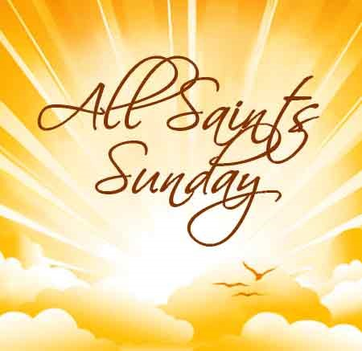

PRELUDE

RINGING OF THE WORSHIP BELL

*CALL TO WORSHIP Psalm 24

Leader: Who shall ascend the hill of the Lord?

People: Those with clean hands and pure hearts.

Leader: They will receive blessing from the Lord,

People: And vindication from the God of Salvation.

OPENING PRAYER

* HYMN “All Hail The Power of Jesus’ Name” No. 155

MINISTRY MOMENT

ALL SAINTS DAY Remembering the Saints Gone Before Us:
Fay Asay, Heather Beuth, John Buzard III, Darwin Haught, Norman King, James Milliron, John Patton, Joyce Shaner, Roberta Williamson

CHILDREN’S TIME

MORNING ANTHEM “Come Be Fed”

OFFERING/OFFERTORY/*DOXOLOGY/*PRAYER OF DEDICATION
*Praise God, from whom all blessings flow: praise Him all creatures here below; Praise Him above, ye heavenly host; praise Father, Son and Holy Ghost. Amen.

JOYS AND CONCERNS/PASTORAL PRAYER/LORD’S PRAYER
*HYMN “There’s Something About That Name” No. 171

SCRIPTURE READING Hebrews 9:11-14 N.T. p. 223
Leader: This is the Word of God, for the people of God,
People: Thanks be to God.

SERMON “THE GREATEST and THE BEST!

HOLY COMMUNION

*HYMN “How Great Thou Art” No. 77

*Altar rail is open for prayer during the closing hymn.

*BENEDICTION
*Please stand in spirit or in body.
Ask an usher for a large print hymnal or bible or personal hearing device.

PRAYER
The Sanctuary will be open on Tuesday, November 5th from 8:00 AM to 2:00 PM If anyone would like to pray for the election.

NOVEMBER MISSION
Our missions for November and December will be donations to the food bank at Grace Presbyterian Church. Please consider making a donation for our community members who may struggle for a quality meal, especially around the holidays. Donations can be left on the alter railing.

DECORATE THE CHURCH FOR CHRISTMAS
Everyone is invited to join us in decorating our church for Christmas Tuesday, November 26, 2024. We begin at 8:30 AM and are usually finished by noon. Come enjoy the fellowship and get in the Christmas spirit.

ADVENT
Advent is coming. The Christian Education team is planning to have an adult Sunday School class (9:30-10:30 AM) during the Advent season. Watch for more details in future bulletins.

CHRISTMAS PRELUDE MUSIC
We are looking for anyone who would like to help provide prelude music prior to our Christmas Eve Candlelight service. Preludes start 30 minutes before the service. Please contact Emily King if you would be willing to share your gift with the congregation at 724-664-0098.

VBS FOR 2025
VBS is scheduled for the week of June 23-27, 2025. Please prayerfully consider where you can fit into this outreach program (teachers, games leader, snacks, monetary, crew leaders, decorations….) watch future newsletters/bulletins for more information.

NOVEMBER SIFT LUNCHEON
The November SIFT Luncheon will be held on Thursday, November 21, 2024, at noon in the Covenant Center. The menu will be Thanksgiving Dinner, turkey, stuffing, mashed potatoes, corn, green beans, cranberries, rolls and butter, pie. The program, Creative Seed Sacks-Louise Baker. Reservations can be made from Monday, November 4th through noon on Monday, November 18th. Please call 724-548-4312. Phone reservations only will be accepted and will be limited to 75. You will need to give a name for each reservation made along with a contact phone number. Please call to cancel as there may be a waiting list. Doors will open at 11:30 AM. Please use the parking lot door. See YOU there!

A JOURNEY TO THE STABLE
“Go back in time to a Biblical Marketplace filled with surprises!”
At Ford Memorial UM Church, Ford City
Saturday, November 30 and Sunday, December 1st
4:00-7:00 PM nightly Open to the public. Free admission.

