FIRST CHURCH WEEKLY CALENDAR
SUNDAY, September 8th
9:30 AM Sunday School
11:00 AM Worship

MONDAY, September 9th
7:00 PM Nurture, Outreach, Witness Team

TUESDAY, September 10th
6:00 PM Women’s Fellowship
7:00 PM New Found Freedom-CC

WEDNESDAY, September 11th

THURSDAY, September 12th
12:00 PM Seniors for Safe Driving-CC
7:00 PM Heavenly Daughters

FRIDAY, September 13th

SATURDAY, September 14th
7:00 PM We Surrender- CC

SUNDAY, September 15th
9:30 AM Sunday School
11:00 AM Worship
October Newsletter Deadline

FIRST UNITED METHODIST CHURCH, 301 N JEFFERSON ST, KITTANNING PA 16201

724-548-4312

E-MAIL: fumchurchkittanning@comcast.net WEBSITE: www.firstchurchkittanning.com

SENIOR PASTOR: Dayton D. Mix PASTOR: Terri Wells CHURCH OFFICE HOURS

CELL PHONE: 724-718-2997 CELL PHONE: 814-952-4695 Monday-Thursday 8:00-12:00

E-MAIL: pastordayton@gmail.com E-MAIL: terriwells53@aol.com

KNOW JESUS, REFLECT JESUS, LEAD OTHERS TO JESUS

THE FLOWERS on the altar are presented to the Glory of God

THANK YOU to the following individuals for assisting with today’s service:
Usher Team: Asbury
Scripture Reader:
Worship Sound System: Hankey training
Bell Ringer: Jocelyn King
Welcome Center Greeter: Melissa Bureau
Acolytes: Caitlyn Kachur
Live Stream: Brenda Beers/Steph Hankey

September 8, 2024

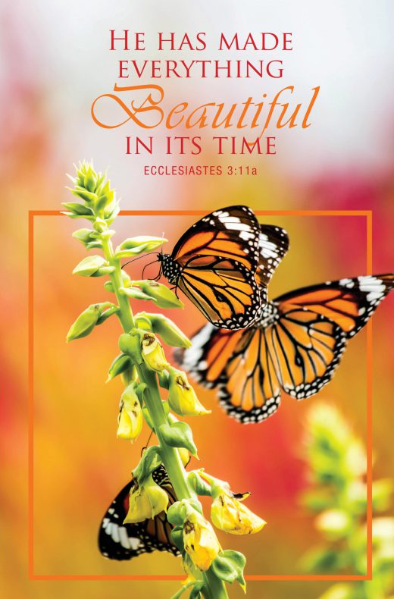

PRELUDE

RINGING OF THE WORSHIP BELL

*CALL TO WORSHIP Psalms 124 & 125

Leader: Those who trust in the Lord

People: Cannot be moved, but abide forever.

Leader: Our help is in the Name of the Lord,

People: Who made heaven and earth.

* HYMN “All Hail The Power of Jesus’ Name” (verses 1-3) No. 154

MINISTRY MOMENT

CHILDREN’S TIME

SPECIAL MUSIC

OFFERING/OFFERTORY/*DOXOLOGY/*PRAYER OF DEDICATION
*Praise God, from whom all blessings flow: praise Him all creatures here below; Praise Him above, ye heavenly host; praise Father, Son and Holy Ghost. Amen.

JOYS AND CONCERNS/PASTORAL PRAYER/LORD’S PRAYER

*HYMN “More Love to Thee, O Christ” No. 453

SCRIPTURE READING Genesis 15:1-6 O.T. p. 12
Leader: This is the Word of God, for the people of God,
People: Thanks be to God.

SERMON “The Pathway to Covenant”

*HYMN “Trust and Obey” No. 467

*Altar rail is open for prayer during the closing hymn.

*BENEDICTION
*Please stand in spirit or in body.
Ask an usher for a large print hymnal or bible or personal hearing device.

SEPTEMBER MISSIONS
The Rise Against Hunger packaging event that we have collected mission money for will be held on Saturday Sept. 14 at Bethel UMC
150 Alder Street Lower Burrell (New Kensington) from 9 to about noon. We need a few more volunteers to help with packing the meals. If you would like to join us that morning to package the meals please contact Emily King 724-664-0098 or the church office 724-548-4312. We will have a carpool leaving the church shortly after 8:00.

CARING FRIENDS REQUEST
The members of the Caring Friends committee are requesting your help to continue their ministry of sending cards to our members. Cards are sent for special occasions and monthly to our shut-ins. Any monetary donations to help cover the ever-increasing cost of stamps would be greatly appreciated. Your donations can be sent to the church office or placed in the offering with the notation for Caring Friends. Thank you very much for your help.

MESSAGE FROM THE NOMINATIONS COMMITTEE
With the recent changes to membership, First United Methodist Church finds itself in need of new leadership. There are vacancies in many necessary positions. If you ever thought of or will consider helping us. Please call Melissa Bureau at 724-859-2607 or church office at 724-548-4312. Thank you for your help.
2025 VBS ALUMINUM CANS
We continue our aluminum can collection for Habitat
for Humanity
Cans Received July 15th—August 15th—5268
Total cans received through August 15th—8865
Many thanks to everyone who is saving aluminum cans and bringing them to the church-at the ramp at the back of the church. Please save cans from soft drinks, juice, power drinks, tea, beer, cat food-Aluminum only-NOT “TIN CANS”, food, soup, etc.
Thank you, The Can Man, Jim Ternent

OUR SIFT LUNCHEONS ARE SET TO RETURN FOR THE YEAR
The September SIFT Luncheon will be held on Thursday, September 19, 2024, at noon in the Covenant Center. The menu will be Ham Bar-be-que sandwich with homemade macaroni and cheese. Dessert will be cake. The program will be presented by a music therapist. Reservations can be made from Tuesday, September 3 through noon on Monday, September 16. Please call 724-548-4312. Phone reservations only will be accepted and will be limited to 75. You will need to give a name for each reservation made along with a contact phone number. Please call to cancel as there may be a waiting list. Doors will open at 11:30 AM. Please us the parking lot door.
See YOU there!

